

# Ameriya 50'' Upholstered Loveseat

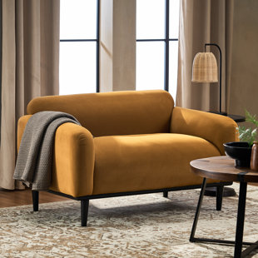

Price

$1,480

This loveseat's contemporary silhouette makes it an ideal addition to your den or living room. Crafted with a solid birch wood frame, it features a plush silhouette with round arms and a tight back filled with foam for an overstuffed look that invites you to lounge or read. It's balanced on four tapered dowel legs with a neutral finish and wrapped in polyester fabric for a tailored touch. Top perk: This loveseat supports up to 600 lbs. and resists stains, so it holds up in busy homes.

# Ayda 89'' Upholstered Sofa

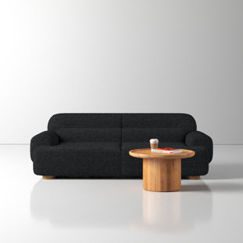

Price

$1,440

Wrapped in lush boucle fabric, this sofa showcases sculptural curves accented by channel tufting + oversized armrests. It’s built with a solid eucalyptus wood frame + rests on rounded wooden legs that mix in material contrast. Low, deep, and generously proportioned, it delivers truly decadent lounging.

# Benedict 91'' Upholstered Sofa

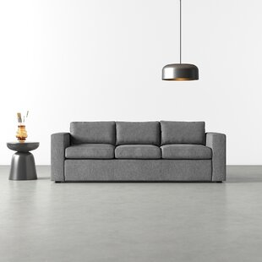

Price

$1,500

With its blocky square arms and low deck, this sofa exudes boldness + stability. It’s built with a solid wood frame and wrapped in performance fabric, plus the cushions are reversible. Go ahead – flop onto it dramatically, plan spaghetti-and-a-movie night, adopt a dog: This couch has your back.

# Berger 98'' Upholstered Sofa

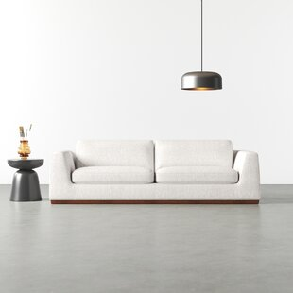

Price

$2,220

This sofa is designed with a clean-lined minimalism that puts the focus on the most important thing: Casual, everyday lounging. It's made with a solid wood frame that's wrapped in a textured polyester blend upholstery. Plus, the upholstery's neutral hue makes it super easy to match, or to use as the stage for some pops of color. Foam and synthetic fiber filling make up the removable seat and back cushions, so you can kick back with plenty of extra padding. Plus, with square arms, a block base, and exposed stitch detail, it anchors your living room with simple minimalism. This sofa requires 29'' of doorway clearance, and arrives fully assembled.

# Brandt 97'' Upholstered Sofa

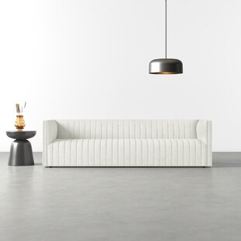

Price

$2,312

Channel retro vibes. This sofa draws on mid-century designs for a modern look in your living space. Crafted with a solid wood frame and upholstered in a polyester blend fabric, this sofa features a clean-lined silhouette with a high back and tuxedo arms for a sleek, squared-off look. Vertical channel and welted seams layer bold texture into your space, and mix in nods to mid-century design elements. It's sized to easily seat up to three people, or makes an excellent spot for a nap for one. Requires a minimum of 26.5'' of doorway clearance.

# Bruno 86.5'' Genuine Leather Sofa

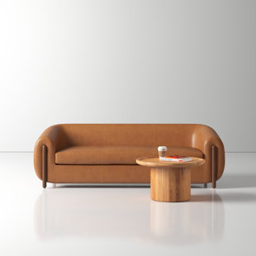

Price

$4,099

The Bruno 86.5'' Genuine Leather Sofa is a luxurious centerpiece for any living space. Crafted with exquisite attention to detail, this sofa boasts a classic yet contemporary design that blends seamlessly with various decor styles. Its generous dimensions of 86.5 inches provide ample seating space for relaxation and entertaining guests. The sofa is upholstered in high-quality genuine leather, offering a sophisticated and inviting feel. The leather not only exudes elegance but also promises durability and easy maintenance.

# Cherryholt 86'' Upholstered Sofa

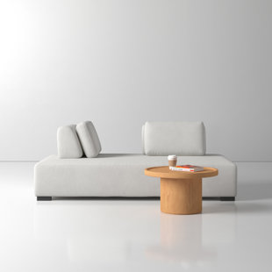

Price

$1,400

Building blocks. Arrange + rearrange these modular sectional pieces to suit your space – or your whims. The seats, non-slip backrests, and cushions form a sofa, chaise, flat sleeping surface, and more. With a kiln-dried wood frame wrapped in resilient upholstery, it’s as strong as it is flexible.

# Clark 81'' Genuine Leather Sofa

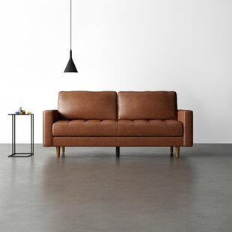

Price

$1,450

Our power couple: mid-century modern design + 100% leather upholstery. This sofa strikes a stylish silhouette, thanks to its tapered legs, square track arms, and single button-tufted seat cushion. Made from a solid kiln-dried oak wood frame and wrapped in top-grain leather for sturdy seat that will only get better with time as it develops a unique patina. The removable cushions are foam-filled and rest on springs for just the right amount of give. The piped trim finishes the design making this an easy staple for your living room.

# Clay 78'' Upholstered Sofa

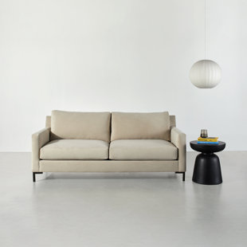

Price

$1,750

Metal bracket legs complement this sofa’s minimalist silhouette, for a look that’s both comfortable + chic. This All-Modern exclusive design is artisan-built in North Carolina, with reversible feather-blend cushions supported by steel sinuous springs. Choose from a range of upholstery options to design your ideal couch – it’s modern made custom.

# Claymont 79'' Upholstered Sofa

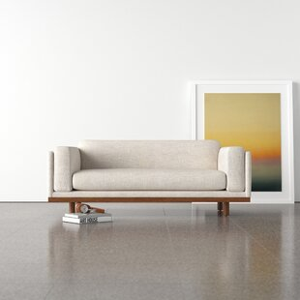

Price

$2,750

Comfy cushions on chunky legs, Claymont is contemporary style and oversize cushy arms. After a long day, it’s exactly where you’ll want to snuggle up. This statement 3-seater sofa features a full wooden rail and head-turning Scandi legs. Claymont will infuse a touch of Danish design into your space.

# Cleo 84'' Upholstered Sofa

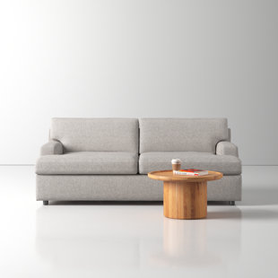

Price

$1,850

Crafted for comfort, this wide-armed sofa features clean lines + plush feather-blend fill. This All-Modern exclusive design is artisan-built in North Carolina, with reversible cushions supported by steel sinuous springs. Choose from a range of upholstery options to design your ideal couch – it’s modern made custom.

# Deans 76'' Upholstered Sofa

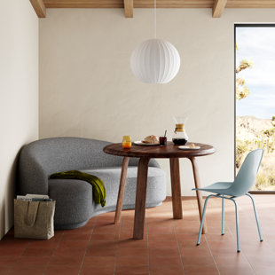

Price

$1,760

Plush boucle fabric complements this sofa’s sculptural curves, for a soft modern silhouette that engages from every angle. A slightly recessed base lends it a floating quality to underscore the cloud-like look. It’s built to last, with a solid kiln-dried wood frame + durable performance upholstery.

# Dehanae Modern Fabric Upholstered Couch with Oak Wood Legs

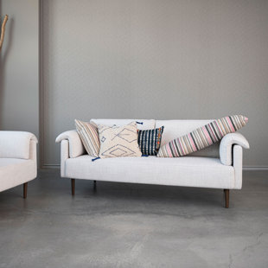

Price

$2,500

Create a space you love with our thoughtfully designed collection of sofas and chairs. Explore a carefully curated selection of pieces including loveseats, rocking chairs, armchairs, swivel chairs, couches, and so much more. Choose from a wide array of materials from supple velvet and linen to reclaimed wood and cotton boucle, and styles from mid-century modern and classic farmhouse to vintage glam and boho. Anchor the design of a living space with a bold focal piece, or simply add touch of personal style to a spare room with an artfully crafted piece of furniture.

# Desi Retro Button Tufted Loveseat

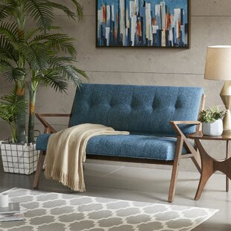

Price

$1,450

Make a statement in your living room, bedroom, or home office with this distinctive modern loveseat. It’s made of solid rubberwood in a warm walnut finish and features sinuous spring construction, foam padding, and polyester upholstery in a solid hue. This loveseat has an eye-catching open frame, with triangular arms and a cushion back. Plus, its seat cushions are removable, so it's a cinch to vacuum up those inevitable crumbs. This 53.75” wide loveseat is just right for smaller living rooms; it completes the look in any mid-century modern or bohemian setting.

# Don 90" Upholstered Sofa

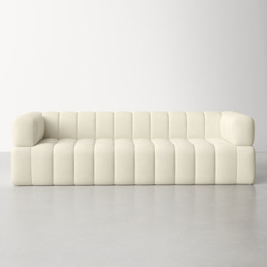

Price

$1,730

Embrace a luxe respite with our elegant and charming Don sofa. The plush contours of our sofa are beautifully highlighted with an allover channeling to bring sophisticated style to your home. Featuring a sheltering back and arms with a generously padded seat, our modern sofa delivers sink-in comfort. It is upholstered in the rich and sumptuous textures of boucle in a graceful light grey hue to complement your formal living space and family rooms alike. A true stunner, our sofa offers a cozy nook perfect for both relaxing and entertaining.

# Elsmere 81'' Upholstered Sleeper Sofa

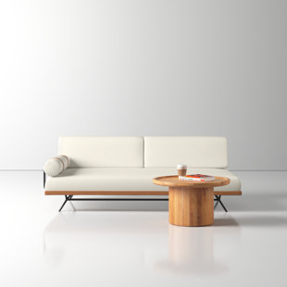

Price

$1,500

A sleeker sleeper. Just remove the back cushions to turn this asymmetrical sleeper sofa into a twin bed – it’s as easy as saying, “you can stay at my place.” Leather accents elevate a minimalist modern silhouette wrapped in performance upholstery. Its bolster pillow can be secured at either end.

# Flipside 86'' Sleeper Sofa Bed

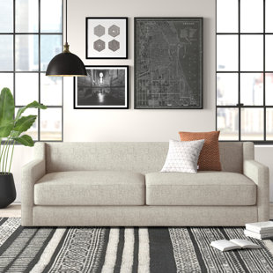

Price

$2,587

This sofabed’s unique design allows it to effortlessly convert from a stylish, modern sofa to a queen-size bed with one quick flip. Loosely arranged back cushions add to the relaxed aesthetic and provide sink-in comfort with luxurious, synthetic-down fill. The flipside features a removable, pre-shrunk, machine-washable cotton top sheet that fastens securely to the bed. The frame is constructed with kiln-dried hardwood.

# Franklin Sofa

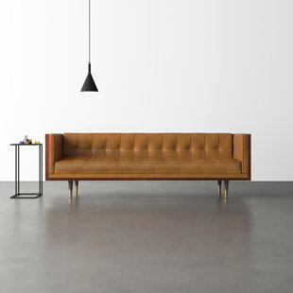

Price

$3,140

Brimming with mid-century modern style, this sofa’s buttery leather upholstery nestles into a sleek hardwood box frame finished with lively walnut veneers. Tailored button tufting and brass-tipped cone legs add polish to the retro silhouette, while a firm seat creates a more formal feel.

# Generation 82'' Upholstered Sofa

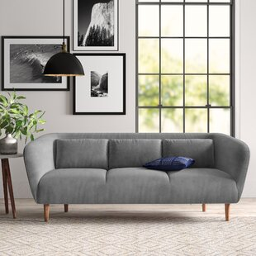

Price

$1,280

Level up your living room with this modern sofa. The sloped back is connected to slim arms that flare at the sides, creating a stylish silhouette. With a tight seat and decorative stitching, this couch has modern style to spare. The solid New Zealand pine frame is upholstered in polyester-velvet for a soft and sturdy touch. The cushions are foam-filled and rest on supportive web suspension. Translation: It’s a super comfy seat. The tapered legs add to the overall modern aesthetic, making this sofa a sure win.

# Geo 84'' Upholstered Sofa

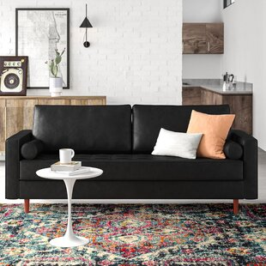

Price

$1,830

Tidy track arms, tapered dowel legs, and a button-tufted bench seat give this bestselling sofa its classic mid-century modern style. Built with a solid wood frame, it comes in a range of fabric options – so it’s easy to find the one for you. Bolster pillows + welted seams complete the tailored retro look.

# George 82'' Upholstered Sofa

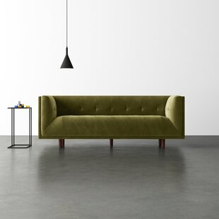

Price

$1,880

Modern style meets a vintage vibe with this streamlined with this sofa. Crafted with a kiln-dried solid wood frame, it's upholstered with velvet fabric in a solid hue. This sofa is padded with foam for a medium seating firmness, and the seat is supported by sinuous springs. Tuxedo arms, conical wood legs in a warm pecan finish, and tufted details complete the look. This sofa seats four and requires a minimum 30" of doorway width for clearance.

# Idana 89.7'' Upholstered Sofa

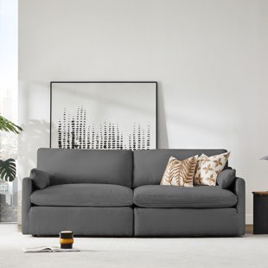

Price

$1,530

As one of the most loungeable seatings in the world, this deep-seated modular sofa creates the ultimate oasis for you and your family to pile on and sink in. Narrow sloped arms are complemented by a low profile and plushly upholstered cushions to provide a comfortable, chic aesthetic. Available in multiple configurations, the versatile, modular design allows you to fit them almost anywhere, and it's easier to fit through doors and around corners in the moving.

# Jeanette 95" Genuine Leather Square Arm Chesterfield Sofa

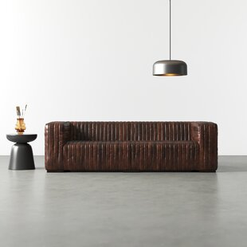

Price

$3,974

Blocky + boldly proportioned, this tuxedo-style sofa delivers deep, generous seating and an industrial-inspired look. It’s built with a solid wood frame and wrapped in channel-tufted leather with a distressed patina that deepens with use. Arrives fully assembled + ready for years of lounging.

# Jesse 87'' Vegan Leather Sofa

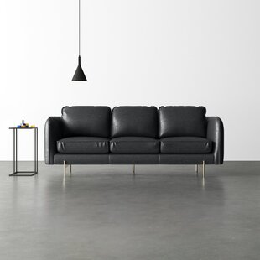

Price

$1,230

This sofa balances its overstuffed cushions with a streamlined silhouette + slim metal legs. Ready for daily lounging, it’s built with a solid eucalyptus wood frame and wrapped in low-maintenance faux leather. Removable + reversible cushions help find the remote – and hide last-minute spills.

# Katrien 93'' Upholstered Sofa

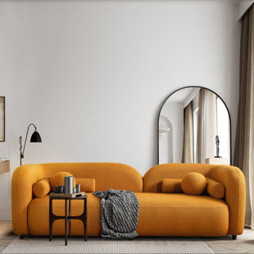

Price

$1,940

Defined by comfortable curves, bold proportions, and a sculptural split backrest, this sofa draws inspiration from the inviting idiosyncrasy of Japandi style. It’s built with a solid eucalyptus wood frame and wrapped in plush boucle. Two bolster pillows + two ball pillows complete the composition.

# Lexi 89" Genuine Leather Square Arm Sofa

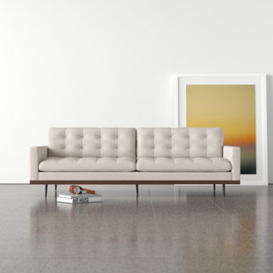

Price

$3,499

Low-leaning style with mid-century vibes. The top-grain leather, with button tufting for texture and comfort. Wrap-around framing and cone-tapered legs for fine finishing touches.

# Miller 84'' Upholstered Sofa

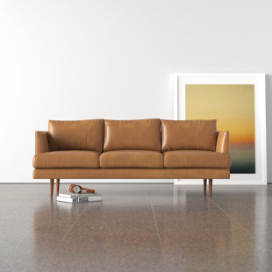

Price

$1,140

Drawing inspiration from mid-century Scandinavian design, this sofa showcases a sleek silhouette accented by cone legs + tapered track arms. It's built with a solid wood frame + wrapped in spill-resistant performance upholstery. Removable cushions make cleaning – and finding the remote – a breeze.

# Pellea 95'' Upholstered Sofa

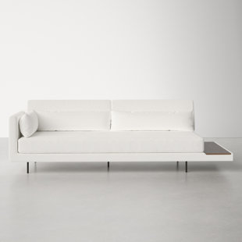

Price

$2,100

This combination sofa and daybed blends functionality and style. Available in two colors, its modern design and built-in side table make it the perfect cozy, contemporary piece.

# Portman 94" Upholstered Sofa

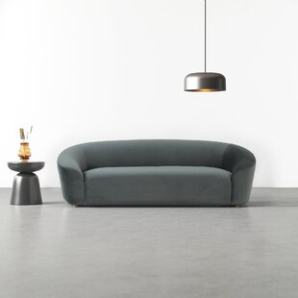

Price

$2,900

Built for laidback lounging, our Portman sofa features a sharp silhouette and broad arms for unparalleled sink-in comfort. Available in linen and velvet options, its plush design and piped stitching are nods to the relaxed modernism of the mid-20th century.

# Wilmette 82'' Upholstered Sofa

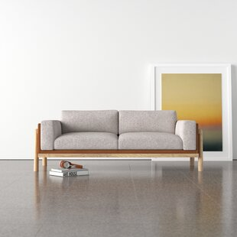

Price

$3,170

Bring Wilmette Scandinavian Modernism center stage in your space with the Wilmette Sofa. The sides and back are draped in buttery soft Full Aniline leather. A sleekly Natural White Oak wooden frame cradles Wilmette seating area. Wilmette keeps its classic Scandinavian design fresh with soft cushions and clean colorways. We wrap it in superior grade leather and give it a limited lifetime warranty. Designed for Kardiel by our U.K design group. Original and we only make 200 each year.



[Ava Sofa / Chair - Sand Linen](https://www.diamondsofa.com/living-room-sofas/8n6gm4i4q8ykrvdmj984bfuoj1b0r8)

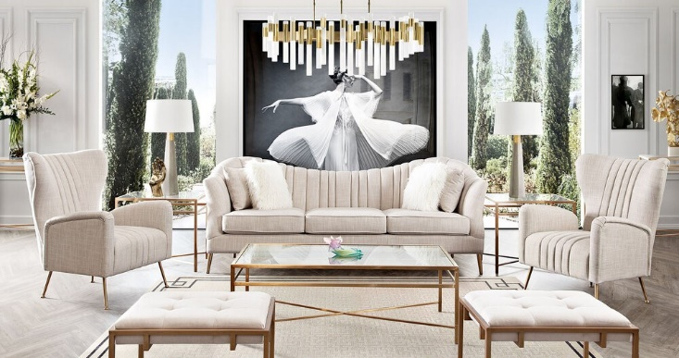

Price

$1,180

The Ava Sofa/Chair boasts a contemporary yet cozy design, featuring clean lines and a sleek silhouette. Upholstered in a soft, sand-colored linen fabric, it exudes an air of sophistication and warmth. The sand hue of the linen adds a touch of elegance to any space, blending effortlessly with various décor styles. Its plush cushions and generously padded seat offer supreme comfort, providing a perfect spot to relax and unwind after a long day. The seat and back cushions are both supportive and luxurious, ensuring a comfortable seating experience.

Ava Sofa / Chair - Emerald Velvet

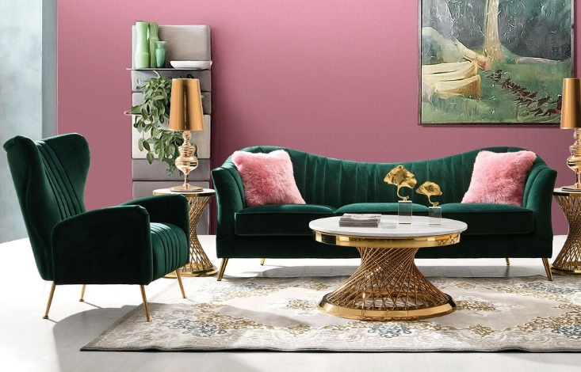

Price

$1,440

The Ava Sofa/Chair in Emerald Velvet exudes sophistication and elegance with its vibrant and rich emerald green velvet upholstery. This luxurious fabric adds a sense of glamour and richness to any space, creating a focal point that captivates the eye. The sofa/chair boasts a classic yet contemporary design, featuring clean lines and a subtly curved silhouette that exudes both comfort and style. The plush velvet upholstery is not only visually stunning but also incredibly soft to the touch, offering a lavish seating experience.

Celine Sofa / Swivel Chair - Light Cream Velvet

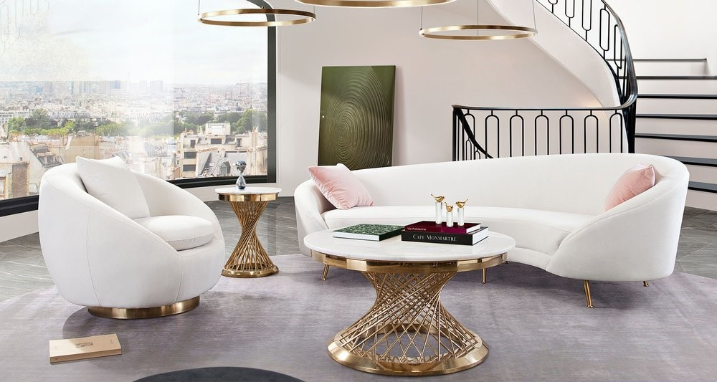

Price

$1,500

Crafted with sophistication in mind, the Celine Sofa/Swivel Chair in Light Cream Velvet epitomizes luxury and comfort. Adorned in a light cream velvet upholstery, this piece emanates a sense of refined grace, imparting a serene and inviting ambiance to any space it occupies. Its design strikes a balance between contemporary chic and timeless style. The plush velvet material not only adds a touch of opulence but also offers a sumptuous seating experience. The light cream hue creates an ethereal and calming presence while effortlessly complementing various interior décor styles. The sofa/swivel chair features a harmonious blend of sleek lines and gentle curves, presenting a visually appealing silhouette. The swivel function of the chair adds a layer of versatility, allowing for easy mobility and adaptability in different settings.

Croft Sofa / Chair

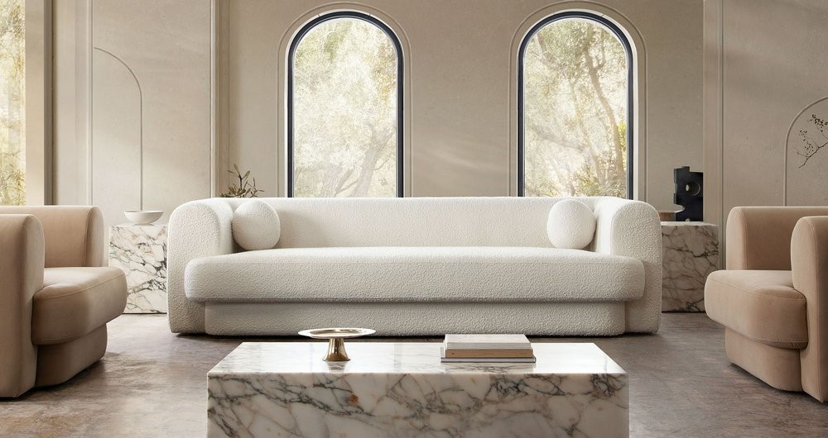

Price

$2,220

Crafted with a focus on sleek lines and minimalist aesthetics, the Croft Sofa/Chair embodies a sense of modern sophistication. Its design is characterized by clean lines and a streamlined silhouette, presenting a versatile piece that complements various interior styles. The sofa/chair features a spacious and inviting seat upholstered in a premium fabric, offering both comfort and durability. The choice of fabric may vary, ranging from linen to velvet or other high-quality materials, depending on the version of the Croft Sofa/Chair. The design emphasizes both comfort and style, with ample cushioning in the seat and backrest ensuring a relaxing seating experience. The proportions are carefully balanced to provide support without sacrificing the contemporary and elegant look.

Envy Sofa/Love

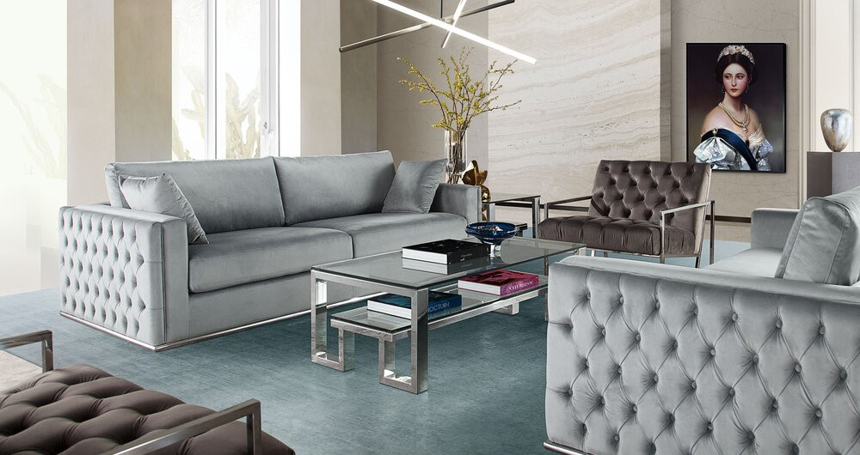

Price

$2,312

The Envy Sofa/Love exudes opulence with its sleek and modern design. Upholstered in high-quality materials, such as velvet or premium fabric, this set radiates elegance and sophistication. The choice of upholstery often varies, allowing for a range of colors and textures to suit different preferences. The sofa/love seat features a contemporary silhouette with clean lines and a plush yet structured form, creating a chic and inviting look. The cushions are generously padded to offer exceptional comfort while maintaining a tailored and stylish appearance.

Image Sofa / Chair - Platinum Grey / Silver

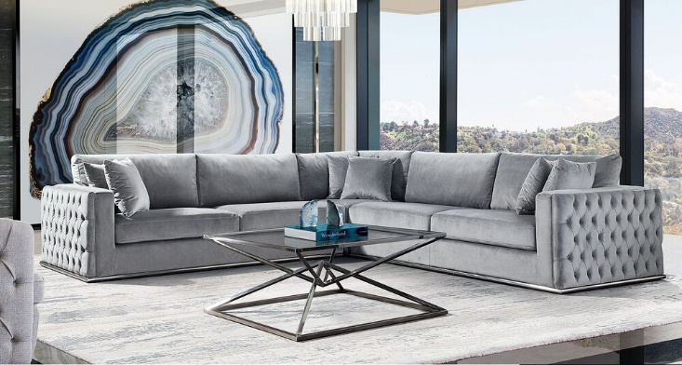

Price

$4,099

Adorned in a Platinum Grey/Silver color scheme, this sofa/chair set boasts a contemporary yet refined aesthetic. The upholstery features a luxurious platinum grey fabric with silver accents or details, adding a touch of glamour and sophistication to any room. The design of the Image Sofa/Chair is characterized by sleek lines and a chic silhouette, creating a visually appealing and modern look. The choice of materials often involves high-quality fabric or velvet, offering a combination of comfort and durability. The sofa and chair are tailored with plush cushions and a well-padded seat, providing exceptional comfort while maintaining a structured and stylish appearance. The thoughtful proportions and ergonomic design ensure a comfortable lounging or seating experience.

Lane Sofa / Chair

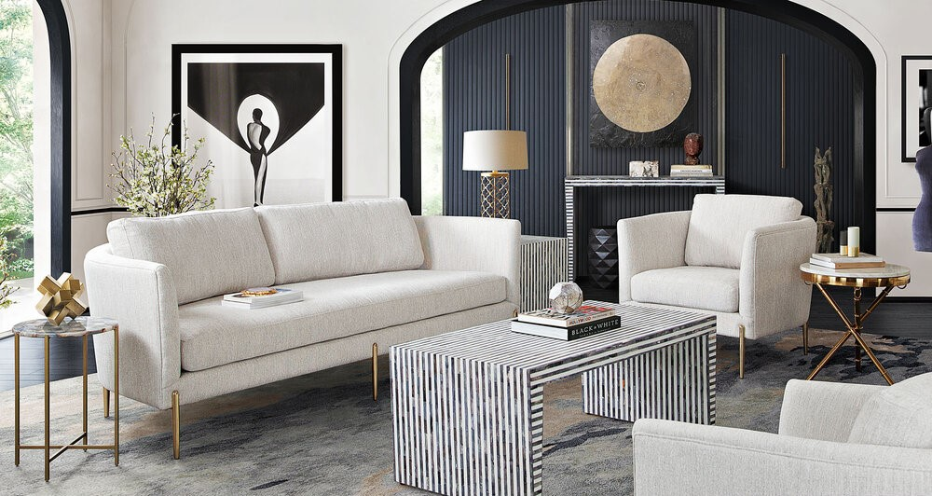

Price

$1,400

The Lane Sofa/Chair features a contemporary yet versatile design, characterized by clean lines and a refined silhouette. Its upholstery typically showcases high-quality materials like fabric or leather, providing both durability and a luxurious feel. The sofa/chair boasts a spacious seating area with generously padded cushions, ensuring a comfortable and inviting experience for relaxation or social gatherings. The design strikes a balance between plush comfort and a tailored, sleek appearance. The color and texture options for the Lane series may vary, offering versatility to suit different interior styles and preferences. From neutral tones to bolder hues, the upholstery choices cater to a wide range of decor schemes.

Muse Sofa / Chair

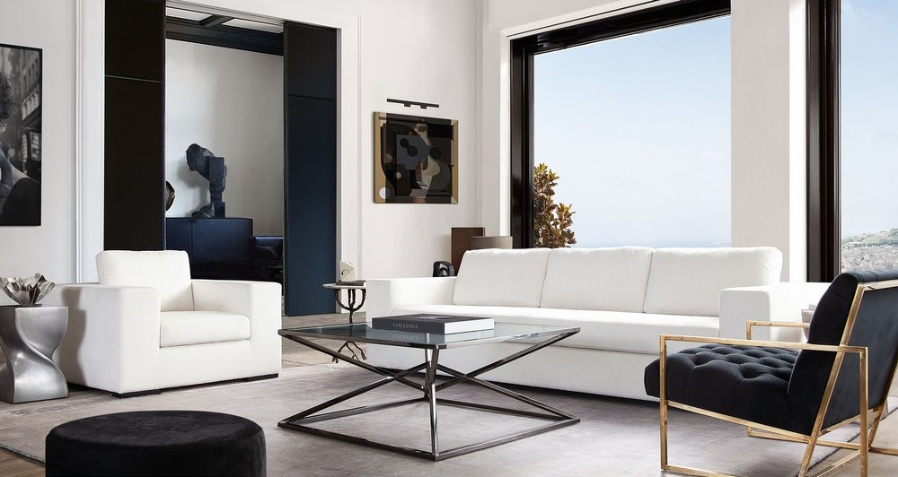

Price

$1,450

The Muse Sofa/Chair boasts a sophisticated and chic design, characterized by clean lines and a graceful silhouette. Upholstered in high-quality materials like velvet or premium fabric, this set exudes luxury and refinement. The sofa/chair showcases a versatile yet distinctive design, offering a choice of colors and textures to suit various interior aesthetics. Whether in neutral tones or bold hues, the upholstery emphasizes both elegance and durability. Both the sofa and chair are generously cushioned, providing a comfortable seating experience while maintaining a tailored and stylish appearance. The design emphasizes a balance between plush comfort and a sleek, contemporary look.

Paloma 3PC

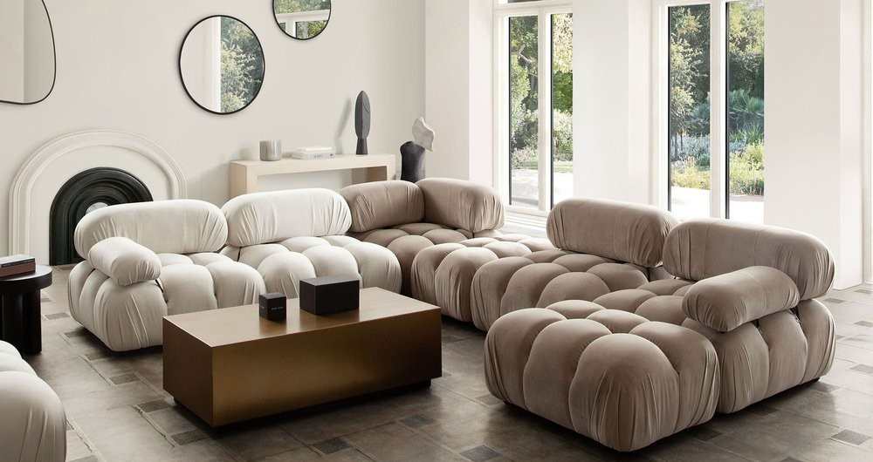

Price

$1,750

The Paloma 3PC set typically consists of a sofa, loveseat, and chair, creating a cohesive and inviting seating arrangement. Each piece in this ensemble is crafted with a focus on modern design and comfort, offering a harmonious blend of luxury and functionality. Adorned in high-quality upholstery, such as premium fabric or leather, the Paloma set exudes elegance and durability. The choice of upholstery may vary, presenting options in different colors, textures, and finishes to complement diverse interior decor preferences. The design of the sofa, loveseat, and chair emphasizes contemporary aesthetics with clean lines and a sophisticated silhouette. The pieces are tailored with plush cushions and well-padded seats, ensuring a comfortable lounging or seating experience for you and your guests.

Pascal Sofa / Swivel Chair - Bone Boucle

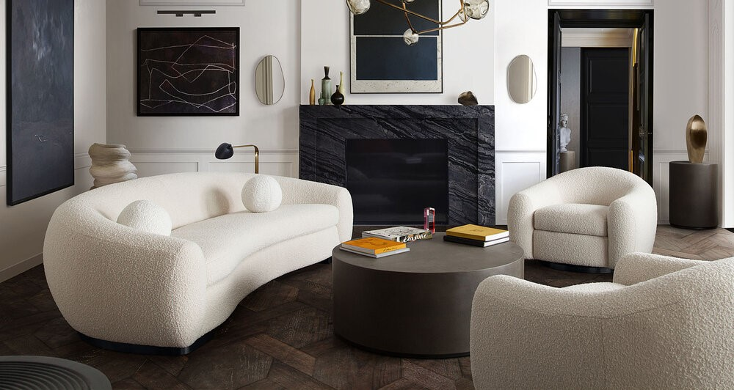

Price

$2,750

Adorned in Bone Boucle upholstery, the Pascal Sofa/Swivel Chair exudes sophistication and elegance. The Bone Boucle fabric adds a textural element, offering both visual interest and a luxurious feel to the set. The design of the sofa and swivel chair strikes a balance between contemporary chic and timeless style. Clean lines and a subtly curved silhouette contribute to a visually appealing and modern look, while the Boucle texture adds depth and dimension to the pieces. Both the sofa and swivel chair are designed with plush cushions and well-padded seats, ensuring a comfortable and inviting lounging or seating experience. The Boucle fabric provides a soft and cozy feel, inviting relaxation while maintaining a refined appearance. The swivel function of the chair adds versatility and ease of movement, allowing for adaptability in different settings or social gatherings.

Raven Sofa / Chair- Light Cream Fabric

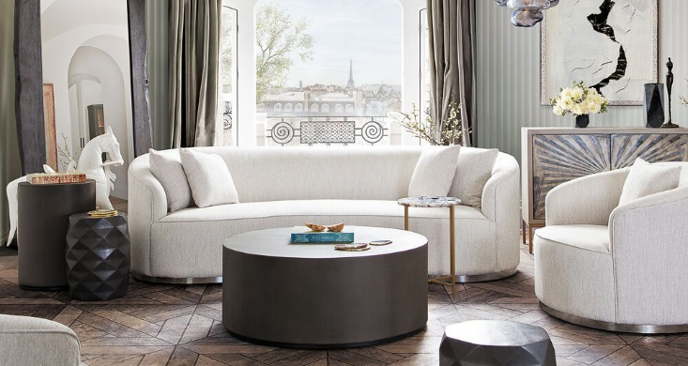

Price

$1,850

The Raven Sofa/Chair, upholstered in a light cream fabric, exudes a sense of understated elegance. The choice of fabric enhances the set's versatility, offering a soft and inviting texture while complementing various interior design styles. The design of both the sofa and chair showcases a blend of classic elements and modern sophistication. The silhouette is tailored with clean lines, offering a sleek and timeless appearance that can effortlessly complement different decor aesthetics. Featuring generously padded cushions and a well-crafted seat, the sofa and chair provide comfort without compromising on style. The light cream fabric adds a subtle yet luxurious touch, creating an inviting seating experience perfect for relaxation or social gatherings.

Savannah Slipcover - Sand Linen

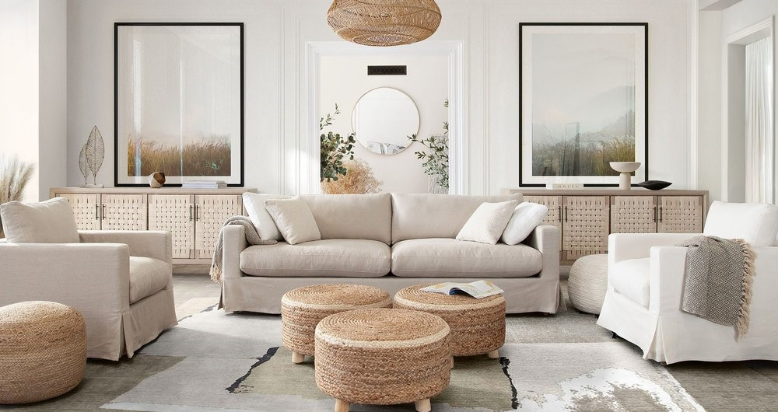

Price

$1,760

The Savannah Slipcover in Sand Linen typically embodies a relaxed yet sophisticated aesthetic. Sand Linen suggests a soft, warm hue reminiscent of sandy beaches or sun-bleached linen. It exudes a natural, earthy tone with a subtle touch of elegance. Linen fabric brings a sense of casual comfort and breathability. It's lightweight and often characterized by its slightly textured surface, adding a tactile dimension to the slipcover. The Savannah Slipcover design tends to prioritize a loose, flowing fit, offering a laid-back charm. It might feature details like pleats, ties, or a draped appearance, enhancing its relaxed yet tailored look. The Sand Linen color complements various decor styles, from coastal and farmhouse to contemporary settings. It brings a sense of warmth and tranquility to a room while offering a versatile canvas for accentuating different design elements.

Seattle Sofa / Love - White Linen

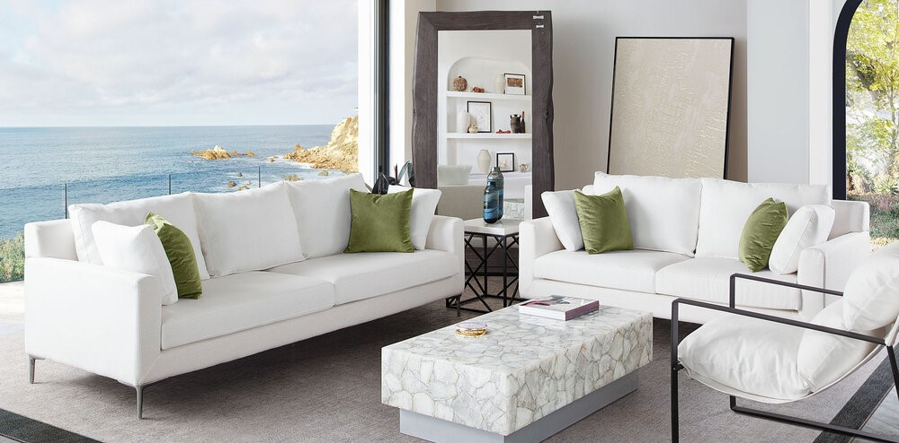

Price

$2,500

The Seattle Sofa/Love in White Linen offers a crisp, clean, and contemporary aesthetic. White Linen denotes a pristine, pure hue, symbolizing cleanliness and sophistication. It creates an impression of spaciousness and brightness within a room, serving as a versatile backdrop for various design schemes. Linen fabric brings a blend of elegance and comfort. It often embodies a smooth, refined texture with a hint of natural irregularities, adding depth to the overall appearance while offering a breathable and soft feel. The Seattle Sofa/Love likely embodies modern design cues with clean lines, minimalistic details, and a streamlined silhouette. Its structure could be angular and sleek, contributing to a contemporary and chic look. White Linen furniture tends to be versatile, complementing a wide range of interior styles, from minimalist and Scandinavian to eclectic or industrial. It can serve as a focal point or seamlessly blend into different design aesthetics.

Simone Sofa / Swivel Chair

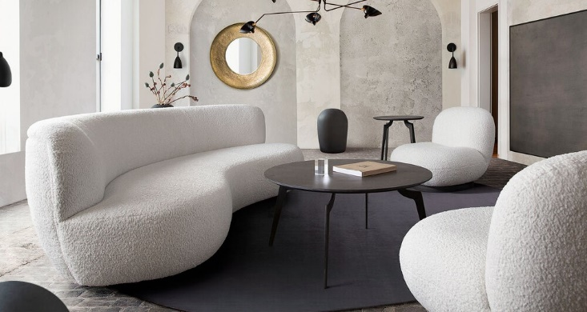

Price

$2,450

The Simone Sofa/Swivel Chair is a modern and versatile furniture piece that combines functionality with contemporary style. The Simone Sofa/Swivel Chair typically embodies a sleek and modern design. It might feature clean lines, a minimalist silhouette, and a focus on both style and comfort. The swivel chair aspect adds a dynamic element, allowing for flexibility in seating positions. The upholstery choice might vary, ranging from durable fabrics to premium leather, depending on the specific design. This variety allows for customization to suit different preferences and interior aesthetics. It often comes in a range of sophisticated and neutral colors, such as charcoal gray, muted blues, or soft beige tones. These colors contribute to its versatility, allowing it to seamlessly integrate into various interior design themes.

Venus Sofa / Chair - Blush Velvet

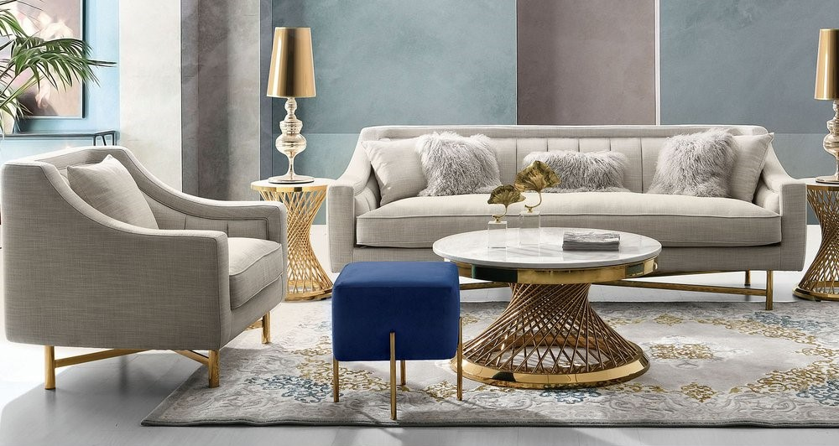

Price

$1,730

The Venus Sofa/Chair in Blush Velvet is an embodiment of elegance and luxury with a touch of softness and sophistication. Blush Velvet exudes a delicate, pale pink tone that's reminiscent of soft petals or a rosy sunset. It carries a sense of subtlety and grace, adding a gentle warmth to any space. Velvet fabric brings opulence and a tactile richness. Its plush, tufted surface creates a luxurious feel, offering a velvety softness that's inviting and comfortable to the touch. The Venus Sofa/Chair likely boasts a refined and classic design with graceful curves, subtle detailing like tufting or piping, and possibly elegant tapered legs. Its silhouette may reflect a blend of vintage charm and modern sophistication.

Vesper 2PC

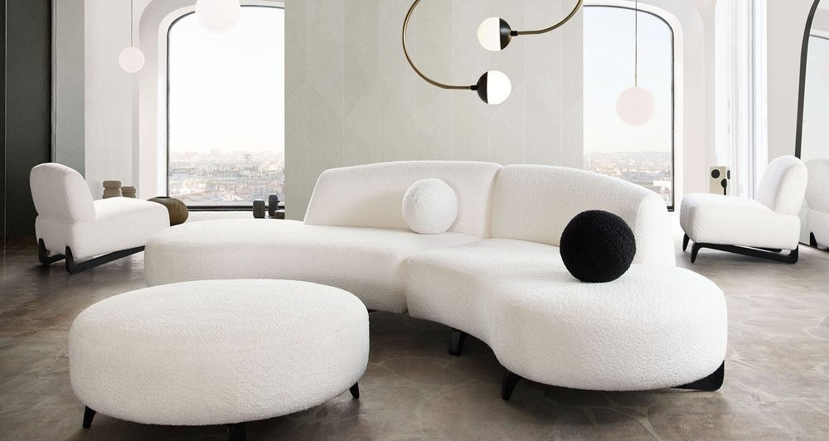

Price

$1,500

The Vesper 2PC set likely consists of two cohesive pieces of furniture, possibly a sofa and a loveseat, a sofa and an accent chair, or another combination designed to harmonize in style and aesthetics. The design could feature clean lines, a modern silhouette, and contemporary detailing. It might incorporate elements such as sleek legs, minimalistic arms, or tailored upholstery, presenting a cohesive and coordinated look between the two pieces. The upholstery material may vary based on the specific design, ranging from fabric to leather or other durable and comfortable materials. The choice of upholstery can significantly influence the set's overall style and feel. The color scheme might include neutral tones like gray, beige, or charcoal, allowing for versatility in various interior design schemes. It could also feature subtle patterns or textures to add depth to the pieces.

Vox Sofa / Chair

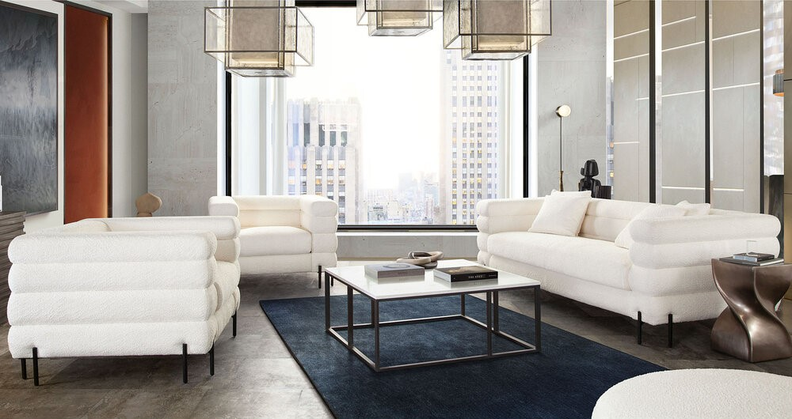

Price

$2,587

The Vox Sofa/Chair represents a contemporary furniture set designed to combine style, comfort, and functionality. The Vox Sofa/Chair set likely features a sleek, modern design characterized by clean lines, a minimalist silhouette, and possibly angular or geometric shapes. Its overall aesthetic might reflect a balance between sophistication and simplicity. The upholstery could vary, ranging from fabric to leather or other durable materials, depending on the specific design. The choice of upholstery influences both the set's style and comfort. It might come in a range of neutral tones like charcoal, gray, beige, or even bold hues, offering versatility to suit different interior decor styles. The color palette could contribute to the set's ability to blend in or stand out as desired.



# Arlo Reclining Sofa

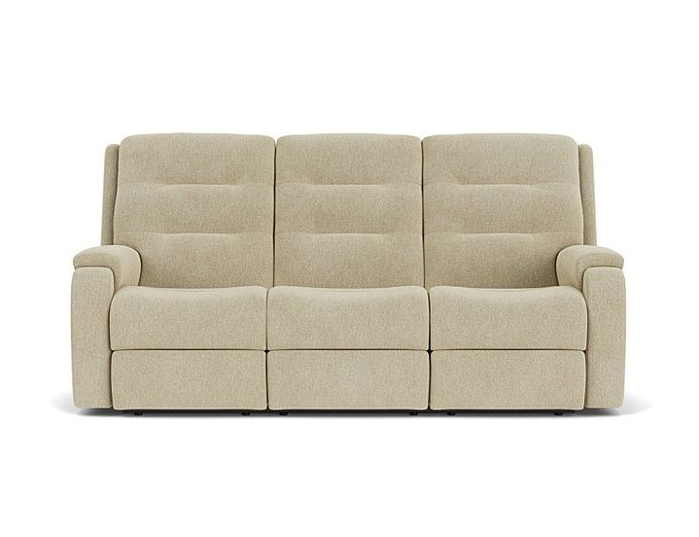

Price

$1,850

Make it a cozy night in with the Arlo Reclining Sofa, which features an easy-to-use handle for adjusting the footrest and recline. The simple yet sophisticated design has a contemporary aesthetic with pull-tufted, triple-divide back cushions that support your head, neck and lower back. Rounded pad-over track arms take pressure off your forearms, helping you relax as you settle in for the evening. Our patented DualFlex Spring System™ ensures years of flexibility and firmness as you sit. Choose from over 250 highly durable, cleanable fabrics that will complement your decor and continue to look good even in high-traffic environments.

# Bay Bridge Sofa

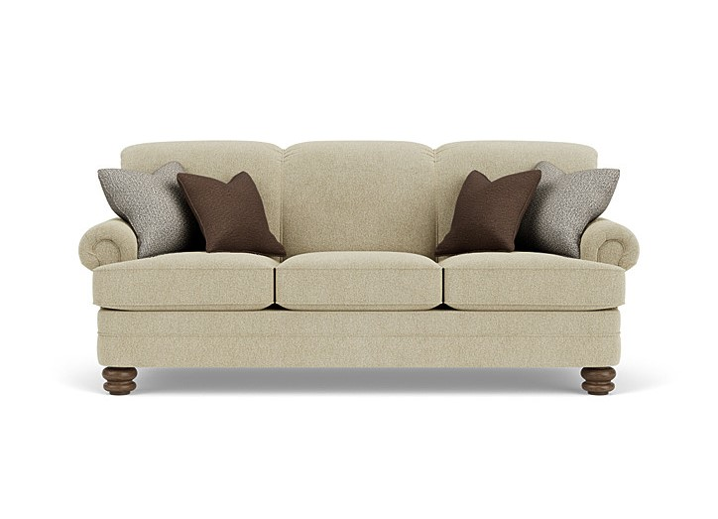

Price

$1,950

The Bay Bridge Sofa is a classic and inviting piece of furniture designed to offer comfort and timeless style. Known for its traditional yet versatile design, this sofa typically features a more formal appearance compared to contemporary styles. Crafted with attention to detail, it often embodies elegance and sophistication. These sofas are often constructed with high-quality materials, including sturdy frames made of hardwood, providing durability and stability. The upholstery can vary, commonly offered in fabric or leather, with a focus on both luxurious feel and long-lasting resilience.

# Bexley Sofa

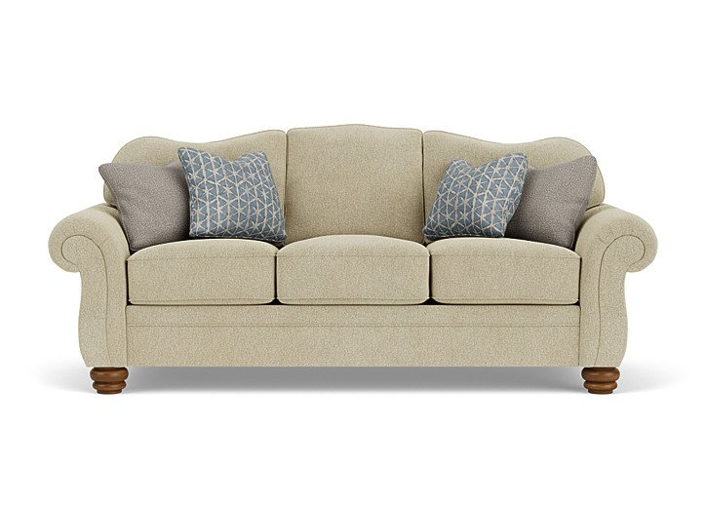

Price

$1,890

The Bexley Sofa is a stylish and comfortable piece of furniture designed for lounging and relaxation. Typically featuring a contemporary or transitional design, it often incorporates clean lines, plush cushions, and a sleek silhouette. The sofa is usually crafted with high-quality upholstery materials like fabric or leather, offering both durability and aesthetic appeal. The Bexley Sofa commonly comes in various sizes, from compact two-seaters to spacious sectionals, catering to different room dimensions and seating needs. Its design often prioritizes comfort without compromising on style, making it suitable for various interior decor themes, whether modern, traditional, or eclectic.

# Bryant Sofa

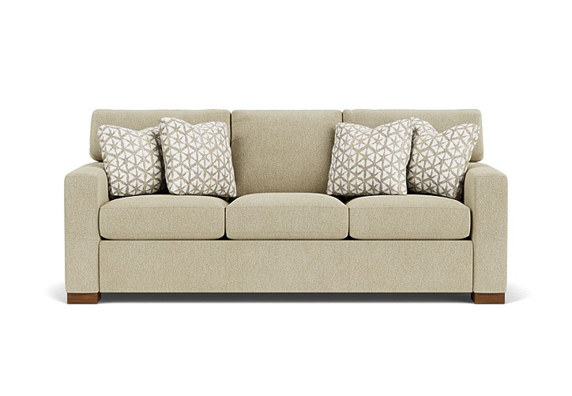

Price

$1,920

The Bryant Sofa is a stylish and versatile piece of furniture known for its modern design and comfortable features. Typically, it boasts clean lines, a tailored appearance, and often has plush cushions for added comfort. The sofa is usually crafted with high-quality materials, such as durable upholstery fabrics or leather, and may come in various colors and finishes to suit different interior aesthetics. Some versions of the Bryant Sofa also include additional features like adjustable headrests or reclining capabilities, making it adaptable to different preferences. Overall, it's a popular choice for those seeking a blend of contemporary style and coziness in their living spaces.

# Carson Sofa

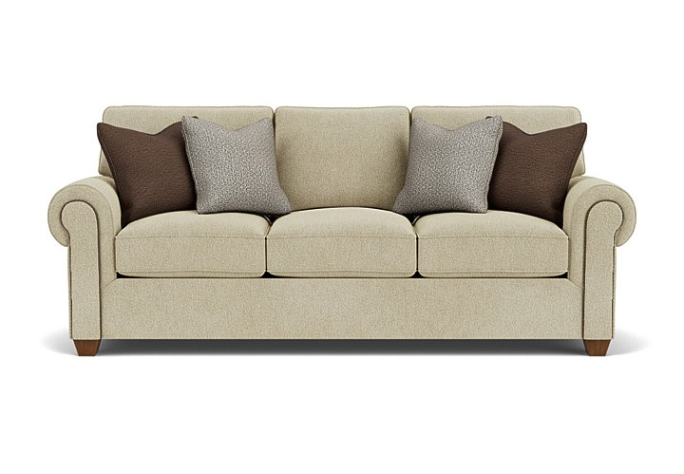

Price

$1,980

The Carson Sofa is a sophisticated and elegant furniture piece that often embodies a classic yet modern design. It typically features a sleek silhouette with clean lines, offering a refined and timeless appearance. The sofa is often characterized by its high-quality craftsmanship and attention to detail, with elements like carefully tailored upholstery and well-defined edges. The Carson Sofa often prioritizes comfort, featuring plush cushions and ample seating space. Its construction may include durable and luxurious materials, such as premium fabrics or top-grain leather, ensuring both style and longevity. Depending on the model, the sofa might come in various colors, allowing it to complement a wide range of interior design themes.

# Catalina Reclining Sofa

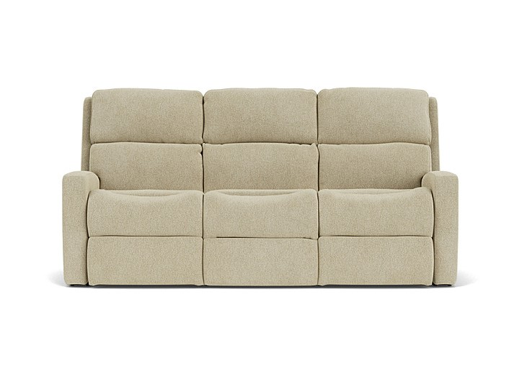

Price

$1,950

The Catalina Reclining Sofa is a luxurious and functional furniture piece designed for comfort and relaxation. Typically, it features a contemporary yet inviting aesthetic, combining both style and practicality. This sofa is engineered with reclining capabilities, allowing individuals to adjust and recline the backrest and footrest to their preferred positions. The reclining mechanism is often smooth and easy to operate, providing multiple levels of comfort for different seating preferences. Contemporary-styled comfort invites all-day lounging with the Catalina reclining sofa. Easily recline back and unwind in either end seat with the pull of a handle in the arm. Catalina's deep-set back wings and sloped arms offer a sleek aesthetic for living spaces, while contoured seats, fully padded footrests and divided back cushions provide support for complete relaxation.

# Collins Two-Cushion Sofa

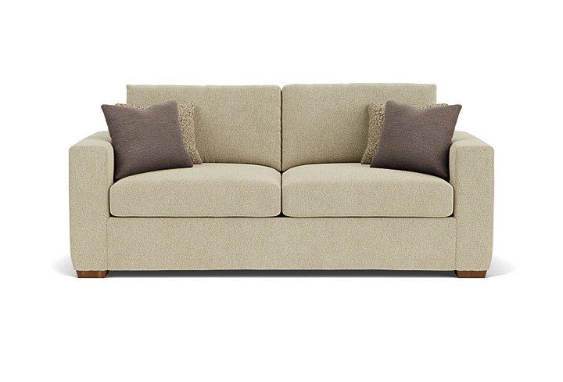

Price

$1,890

Clean lines and ultra-comfy seats will make you want to lounge a little longer on our Collins sofa. Generous in scale to offer up plenty of room to relax, Collins is distinguished by large, lofty cushions and wide track arms that sit on bold block legs for a timeless, casual look that begs you to curl up and get comfortable. Offered in your choice of upholstery and finishes, this sofa can be customized to suit your personal style. The Collins Two-Cushion Sofa is a classic yet modern piece of furniture designed for both style and comfort. Typically, it features a sleek silhouette with clean lines and two generously-sized cushions for seating. The sofa often boasts a hardwood frame for durability and is upholstered in high-quality fabric or leather, providing a luxurious feel.

# South Haven Sofa

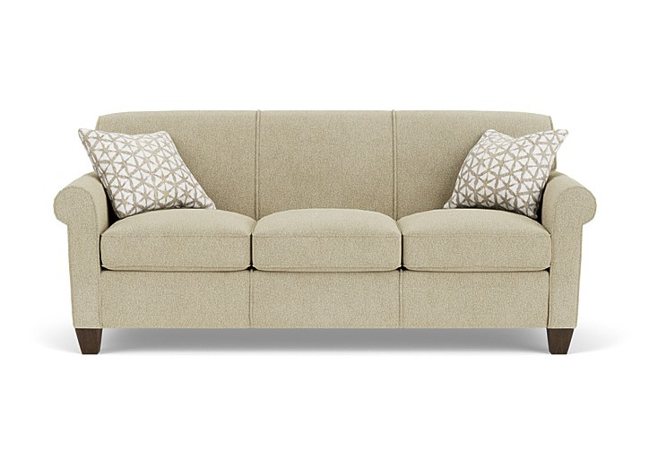

Price

$1,920

South haven sofa is current and stylish, yet simple enough to withstand the test of time. This modestly scaled style is a great option for small spaces. With a tightly padded back, tailored roll arms and tall tapered feet, South haven sofa fits classic touches into a streamlined design that lends openness to any space. The South Haven Sofa is a contemporary furniture piece known for its sleek and modern design. Typically, it embodies clean lines, a low-profile silhouette, and a minimalist aesthetic that exudes sophistication. This sofa often features a sturdy frame, commonly constructed from materials like hardwood or metal, providing durability and stability. Its design often emphasizes a streamlined appearance, with slender arms and legs contributing to its modern look. Upholstered in high-quality fabric or leather, the South Haven Sofa is available in various colors and textures, allowing for versatility in matching different interior design styles. The upholstery is often selected for its durability, comfort, and visual appeal.

# Davis Reclining Sofa

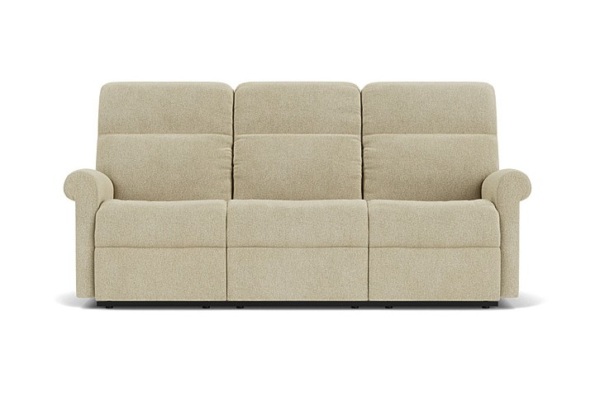

Price

$1,980

Davis features a rolled arm that slopes back for a sharp look, adding to its clean, tailored appeal. Slight contoured seating cradles you while the divided back cushion and fully padded footrest provide comfort for your tired feet. A smooth reclining mechanism lets you change angles effortlessly from an upright to a fully reclined position. The Davis Reclining Sofa is a luxurious and comfortable furniture piece designed for relaxation and convenience. Unlike traditional sofas, this model features built-in reclining mechanisms that allow individuals to adjust the seating positions for optimal comfort. Typically, the Davis Reclining Sofa is constructed with a sturdy frame, often using hardwood or reinforced steel to provide durability and stability. Its design includes padded armrests, a cushioned backrest, and a comfortable seat, all upholstered in high-quality fabric or leather for a luxurious feel.

# Dempsey Sofa

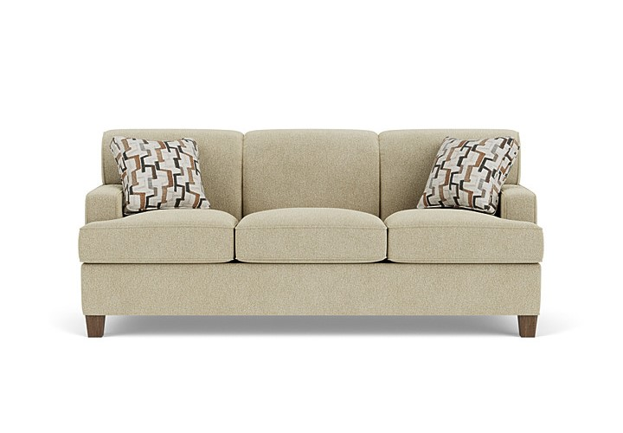

Price

$1,950

With square arms and a curved back lined with welt cording, Dempsey boasts a clean, architectural shape that pairs with any home's decor. This sofa is a perfect choice for new homeowners who are looking for durability in an affordable style. The Dempsey Sofa is a stylish and versatile furniture piece known for its blend of modern design and comfort. It typically embodies a contemporary aesthetic with clean lines, a sleek silhouette, and subtle details that add sophistication to its overall look. Constructed with a durable frame, often using hardwood or engineered wood, the Dempsey Sofa offers a sturdy foundation for long-term use. The sofa's design frequently includes slightly tapered legs that contribute to its modern appearance. Upholstered in high-quality fabric or leather, the Dempsey Sofa comes in various color options and textures, allowing for customization to suit different interior styles. The upholstery is chosen for its durability, comfort, and visual appeal, enhancing the sofa's overall aesthetics.

# Devon Reclining Sofa

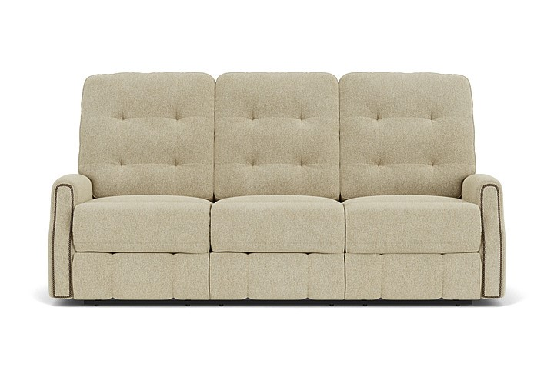

Price

$1,920

Devon's profile includes puckered stitching and a tufted back, which provides contrast and style while delivering extreme comfort and relaxation. Feel content while you lean back and rest your feet on the fully padded footrest. Nailhead trim outlines the front of the arms adding flair to its traditional design. A smooth reclining mechanism lets you change angles effortlessly from an upright to a fully reclined position. The Devon Reclining Sofa is a luxurious and functional furniture piece designed for comfort and relaxation. This type of sofa typically offers built-in reclining mechanisms that allow for easy adjustment of seating positions. Constructed with a sturdy frame, often made from durable materials like hardwood or reinforced steel, the Devon Reclining Sofa ensures stability and longevity. Its design often includes generously padded armrests, a plush backrest, and a comfortable seat, all upholstered in high-quality fabric or leather for a luxurious feel.

# Arlo Reclining Sectional

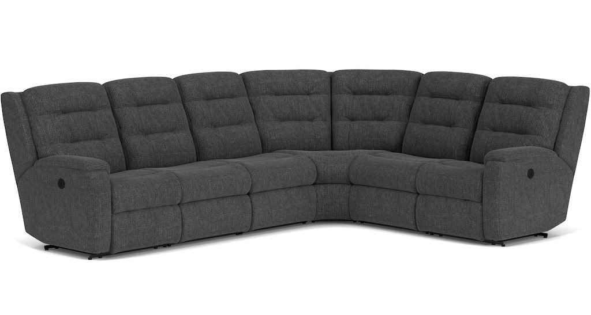

Price

$2,890

Gather the family together for movie night or the big game with the Arlo Reclining Sectional, in modular sections that can be arranged in an L-shape or straight configuration. Enjoy the convenience of a storage console that keeps remotes and beverages right where you need them. You'll all love the comfy pull-tufted, triple-divide back cushions which support your head, neck and lower back as you unwind. Control the recline with smooth-operating handles located in the sides of both arms. Thoughtful features include rounded pad-over track arms that enhance comfort and provide additional forearm support. A contoured seat with chaise pad is great for propping up your feet during movie marathons. And you can enjoy firm yet flexible sitting experience thanks to our patented DualFlex Spring System™. Make Arlo your own by choosing from over 250 fabrics, including our durable, cleanable performance fabrics. The Arlo Reclining Sectional is a spacious and versatile piece of furniture designed for comfort and functionality in larger living spaces. As a sectional, it typically comprises multiple pieces that can be configured to fit various room layouts. Constructed with a durable frame, often using hardwood or reinforced materials, the Arlo Reclining Sectional ensures stability and longevity. The design includes generously padded seats, backrests, and armrests, all upholstered in high-quality fabric or leather for a luxurious and comfortable feel.

# Aurora Power Reclining Sectional with Power Headrests

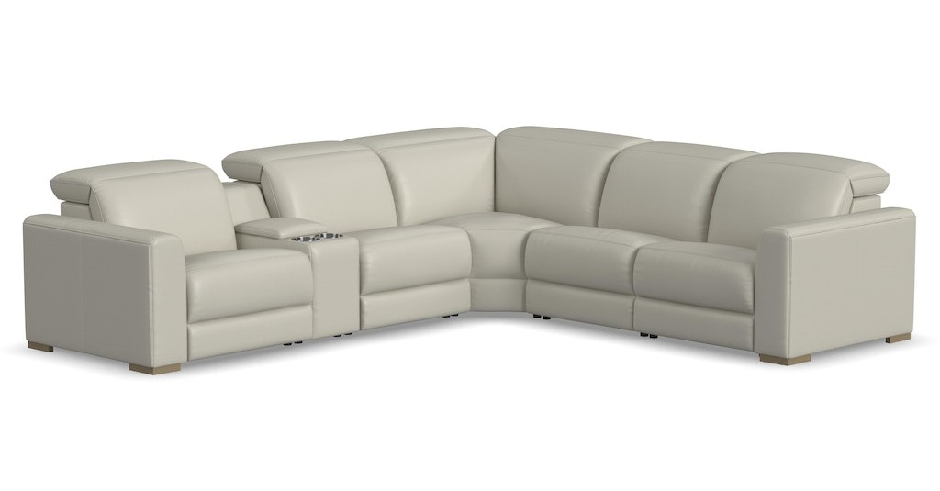

Price

$2,780

The luxurious look of upscale stationary furniture combines with ergonomic adjustability and convenient features with the Aurora power reclining sectional with power headrests. Transform your living space into a stylish oasis for relaxation and surround yourself in contemporary comfort with design features such as soft, wide track arms and a low profile, stationary look with motion functionality. The dual power recline mechanism and power headrests help you achieve maximum relaxation, while Zero Gravity technology gives you a feeling of weightlessness. Useful features such as charging ports and a storage console offer added convenience of keeping mobile devices powered and drinks close at hand. Upholstered in two neutral color choices of durable top grain leather, the Aurora power reclining sectional serves as a beautiful complement to any home. The Aurora Power Reclining Sectional with Power Headrests is a premium and technologically advanced furniture piece designed for ultimate comfort and convenience. This sectional is a luxurious seating solution, typically comprising multiple pieces that can be arranged to fit various room layouts.

# Bryant Sectional

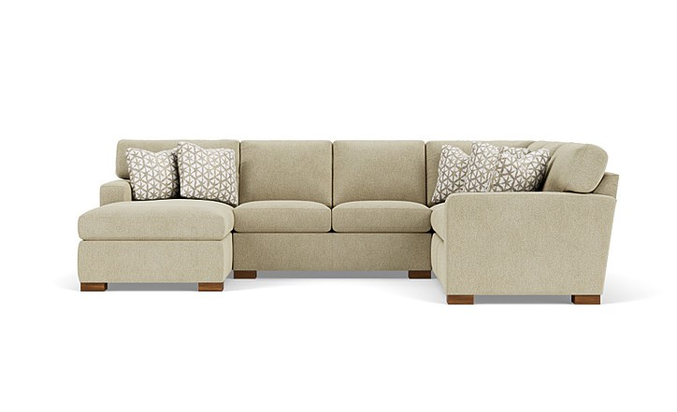

Price

$2,950

Bryant offers modern, clean lines that are contrasted by its softly padded arms and boxed seat cushions. The arms and seat cushions are detailed with single-needle top stitching, while the bold block legs add a solid finish to this design. Multiple seating options make the Bryant sectional ideal for relaxing with company. The Bryant Sectional is a versatile and stylish furniture piece designed to offer comfort and flexibility in various living spaces. As a sectional, it typically consists of multiple pieces that can be arranged to suit different room layouts and preferences. Constructed with a sturdy frame, often using hardwood or durable materials, the Bryant Sectional ensures stability and longevity. The design incorporates generously padded seats, backrests, and armrests, all upholstered in high-quality fabric or leather for a comfortable and inviting feel.

# Catalina Reclining Sectional

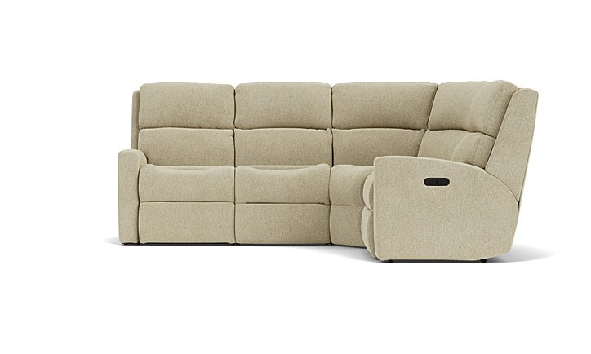

Price

$2,650

Contemporary-styled comfort invites all-day lounging with the Catalina reclining sectional. Easily recline back and unwind with the pull of a handle in the arm. Catalina's deep-set back wings and sloped arms offer a sleek aesthetic for living spaces, while contoured seats, fully padded footrests and divided back cushions provide support for complete relaxation. The Catalina Reclining Sectional is a luxurious and comfortable furniture piece designed for relaxation and versatility. As a sectional, it typically comprises multiple pieces that can be arranged to fit various room layouts, offering ample seating space. Constructed with a sturdy frame, often using hardwood or reinforced materials, the Catalina Reclining Sectional ensures durability and stability. The design includes generously padded seats, backrests, and armrests, all upholstered in high-quality fabric or leather for a luxurious and comfortable feel.

# Collins Sectional

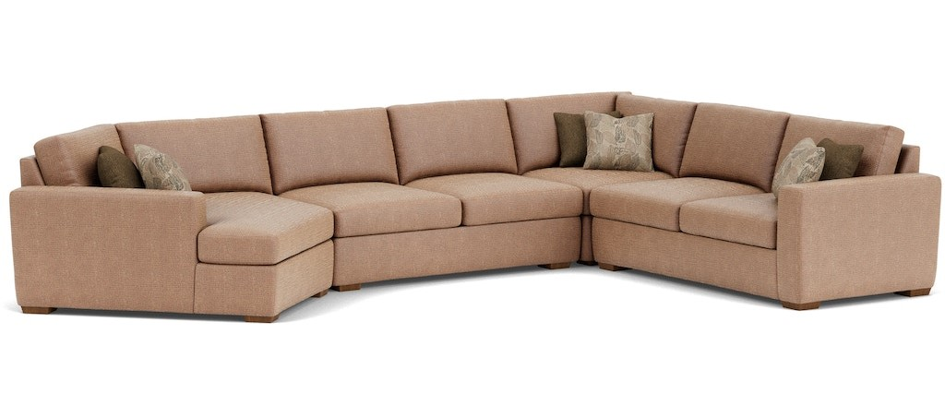

Price

$2,920

Clean lines and ultra-comfy seats will make you want to lounge a little longer on the Collins sectional. Generous in scale to offer up plenty of room to relax, Collins is distinguished by large, lofty cushions and wide track arms that sit on bold block legs for a timeless, casual look that begs you to curl up and get comfortable. With an array of modular components to choose from and your choice of upholstery and finishes, the Collins sectional allows you to create a completely custom look for your space. The Collins Sectional is a sophisticated and versatile furniture piece known for its contemporary design and comfort. As a sectional, it typically comprises multiple pieces that can be arranged in various configurations to suit different room layouts and preferences. Constructed with a sturdy frame, often using hardwood or durable materials, the Collins Sectional ensures stability and longevity. The design incorporates generously padded seats, backrests, and armrests, all upholstered in high-quality fabric or leather for a luxurious and comfortable feel.

# Dana Sectional

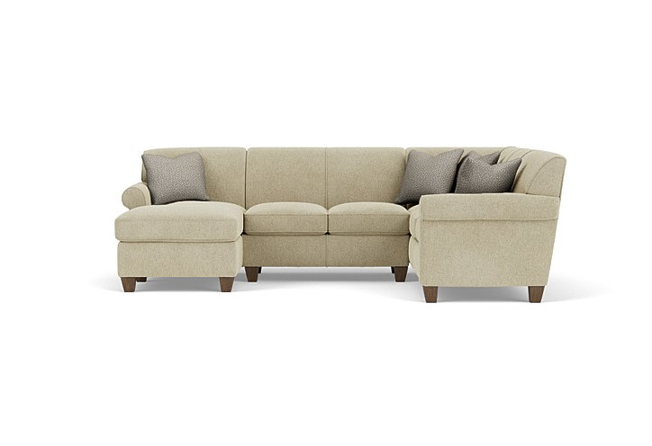

Price

$2,980

Dana is current and stylish, yet simple enough to withstand the test of time. This modestly scaled style is a great option for small spaces. With a tightly padded back, tailored roll arms and tall tapered feet, Dana fits classic touches into a streamlined design that lends openness to any space. Multiple sectional components provide countless configurations to fit any room's shape and scale. The Dana Sectional is a stylish and functional furniture piece designed to offer both comfort and versatility in various living spaces. As a sectional, it typically consists of multiple pieces that can be arranged in different configurations to suit different room layouts and preferences. Constructed with a sturdy frame, often using hardwood or durable materials, the Dana Sectional ensures stability and durability. The design features padded seats, backrests, and armrests, all upholstered in high-quality fabric or leather for a comfortable and inviting feel.

# Davis Reclining Sectional

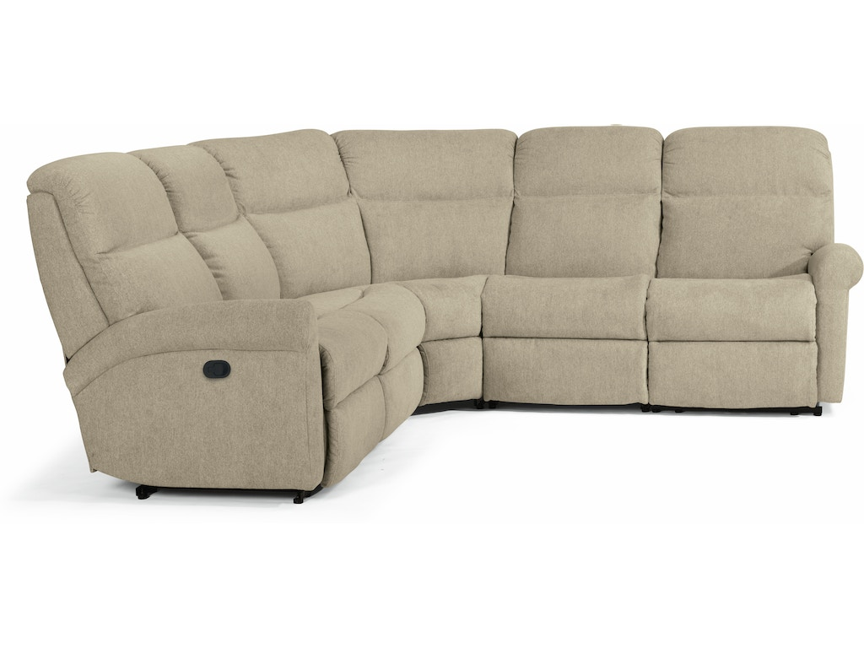

Price

$2,780

Davis features a rolled arm that slopes back for a sharp look, adding to its clean, tailored appeal. Slight contoured seating cradles you while the divided back cushion and fully padded footrest provide comfort for your tired feet. A smooth reclining mechanism lets you change angles effortlessly from an upright to a fully reclined position. The Davis Reclining Sectional is a luxurious and functional furniture piece designed for comfort and convenience in larger living spaces. As a sectional, it typically comprises multiple pieces that can be arranged to fit various room layouts. Constructed with a sturdy frame, often using hardwood or reinforced materials, the Davis Reclining Sectional ensures stability and durability. The design includes generously padded seats, backrests, and armrests, all upholstered in high-quality fabric or leather for a plush and comfortable feel.

# Dempsey Sectional

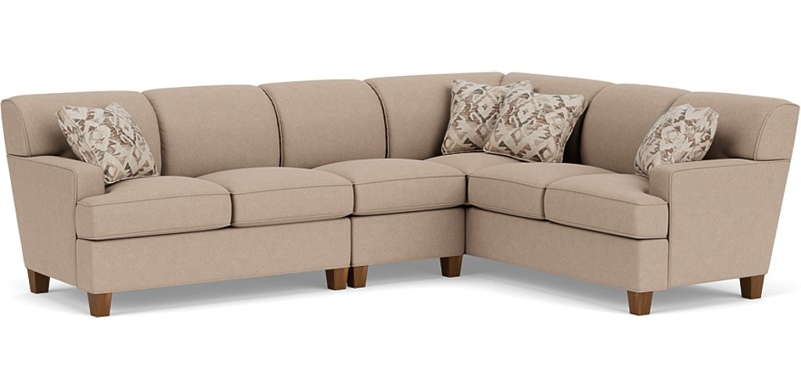

Price

$2,650

With square arms and a curved back lined with welt cording, Dempsey boasts a clean, architectural shape that pairs with any home's decor. This sectional is a perfect choice for new homeowners who are looking for durability in an affordable style. Multiple sectional components provide countless configurations to fit any room's shape and scale. The Dempsey Sectional is a contemporary and versatile furniture piece celebrated for its blend of modern design and comfort. As a sectional, it typically consists of multiple pieces that can be arranged to fit various room layouts and preferences. Crafted with a robust frame, often utilizing hardwood or sturdy materials, the Dempsey Sectional guarantees stability and longevity. The design incorporates well-padded seats, backrests, and armrests, all wrapped in high-quality fabric or leather for a comfortable and inviting seating experience. The Dempsey Sectional often boasts a sleek and minimalist design aesthetic, featuring clean lines and a timeless silhouette that effortlessly complements a wide range of interior decor styles. Its adaptable nature allows for diverse configurations, including L-shaped or symmetrical arrangements, catering to various room sizes and layouts.

# Digby Sectional

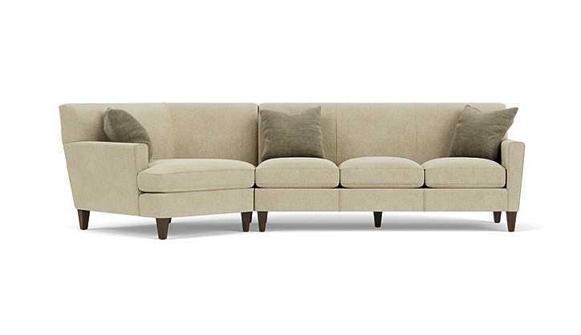

Price

$2,850

Slim tapered arms and a tightly padded back make Digby feel roomy even in smaller areas. Its exclamation-point arm is finished with a tall tapered leg to add visual height, and the tight back enhances the architectural feel of this style while offering surprising comfort. Various seating configurations make the Digby sectional ideal for relaxing with company in any-sized room. The Digby Sectional is a stylish and versatile furniture piece designed to offer comfort and adaptability in various living spaces. As a sectional, it typically comprises multiple pieces that can be configured to suit different room layouts and preferences. Constructed with a sturdy frame, often using hardwood or durable materials, the Digby Sectional ensures stability and longevity. The design features well-cushioned seats, backrests, and armrests, all upholstered in high-quality fabric or leather for a comfortable and inviting feel.

# Finley Sectional

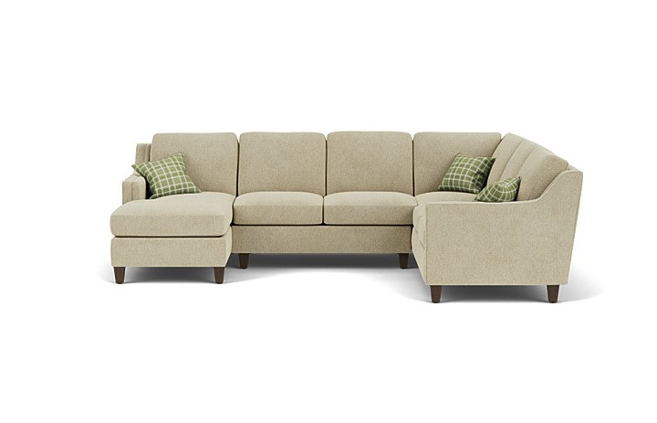

Price

$2,980

Enjoy a cozy spot where the whole family can gather with the Finley sectional. With a high-end look and the comfort of ergonomically designed stationary seating, this sectional features sloped, tapered arms with enhanced padding. An attractive buried welt trim on the arms and cushion edge offers a refined aesthetic. The back cushions are attached, so they stay neatly in place, even if the kids or pets jump on them. And the seat cushions are reversible, so you can rotate or flip them to keep the sectional feeling comfortable and looking fresh. Our patented C-Flex Spring technology ensures that the cushions will stay firm and flexible for years to come. Outfit a sectional that is all your own with accent pillows and a choice from hundreds of fabric options and three wood finish options for the tapered legs. The Finley Sectional is a sophisticated and adaptable furniture piece recognized for its contemporary design and comfort. As a sectional, it typically includes multiple pieces that can be arranged in various configurations to suit diverse room layouts and preferences.



ÄPPLARYD

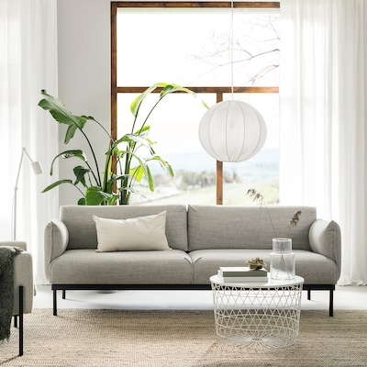

Price

$1,149

ÄPPLARYD sofa will be your home’s comfy oasis. An eye-catcher that reflects your personality and style. Great to sit, lie down and hang out on. And with lots of space for the whole family, year after year. This sofa has an effortless stylishness and straightforward exterior with a well-tailored soft cover and comfortable inner pocket springs. The slim legs reinforce the tranquil and airy look.

ESSEBODA

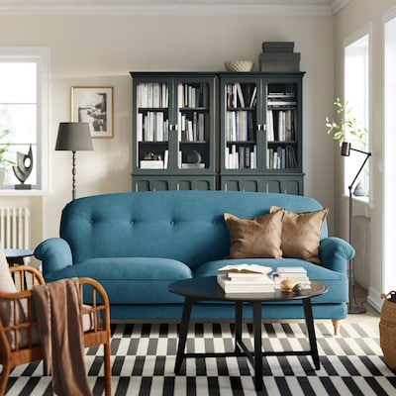

Price

$1,349

Maybe the softest sofa you’ll ever own! The ESSEBODA series spoils you with everything from the sofa's embracing feel, deep seats and high backrests to timeless design, fine details and many possibilities. ESSEBODA sofa stands out with its soft comfort, generous shape and well-thought-out design. It is great throughout the home and can be matched with other items in the series for versatile use. Turned legs, fabric-covered buttons and well-sewn seams give a timeless, elegant and crafted feel.

FINNALA

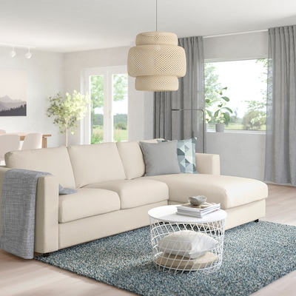

Price

$1,599

FINNALA sectional sofa can grow and change with a home and the family. Choose how many seats, the look and function to create a sofa that suits you. A clean design and long-lasting comfort are included. This comfortable sofa has pocket spring seat cushions with high resilience foam and a top layer of wadding. It provides a nice comfort and support for your body while maintaining the shape of the seat cushions.

FRIHETEN

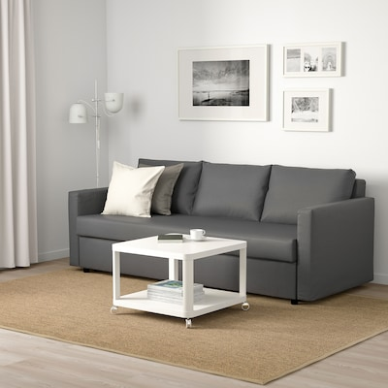

Price

$899

After a good night’s sleep, you can effortlessly convert your bedroom or guest room into a living room again. The built-in storage is easy to access and spacious enough to store bedding, books and PJs. This sofa converts quickly and easily into a spacious bed when you remove the back cushions and pull out the underframe. Sofa, chaise and double bed in one. Storage space under the chaise. The lid stays open so you can safely and easily take things in and out. You can place the chaise section to the left or right of the sofa, and switch whenever you like.

GAMMALBYN

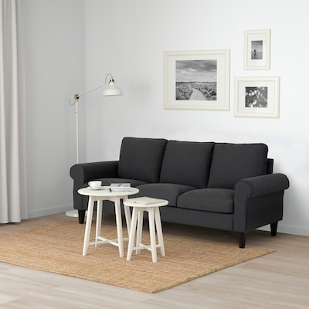

Price

$699

Watch movies or talk to a friend. Read a book or take a break with the family. Email or sleep. Here’s space for everything in your life. Moveable cushions make the sofa comfy for sitting on and lying down. Durable metal springs in the seat give the sofa a springy comfort, allowing you to sit, relax and enjoy it for many years. Seat cushions filled with high resilience foam and polyester fiber wadding provide comfortable support for your body when seated, and easily regain their shape when you rise.

GLOSTAD

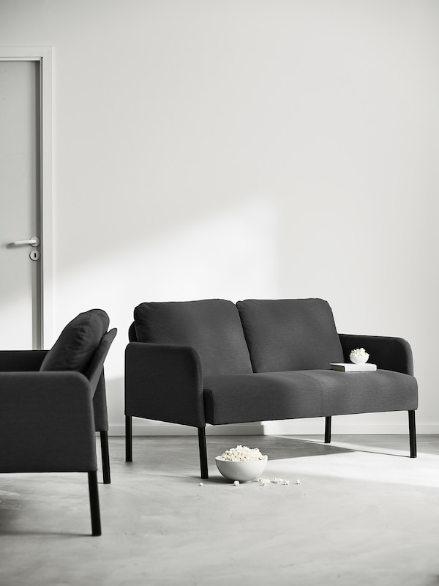

Price

$149

It should be easy to get a sofa, and GLOSTAD sofa is easy to buy, bring home, assemble, and live with. So you can enjoy more time and space to hang out with friends and family and do other important things. GLOSTAD sofa has a simple design which is also comfortable with its thick seat, padded armrests and soft back cushions that sit firmly in place. The sofa's low weight makes it easy to move – in your current home or when moving to a new home. The slightly angled metal legs make the sofa stable, while giving it a personal expression.

HOLMSUND

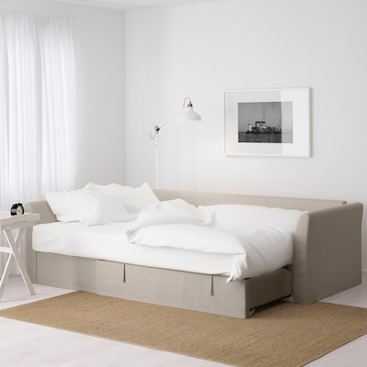

Price

$1,199

This sofa quickly and easily transforms into a spacious bed – and turns the living room into a bedroom. The storage space under the seat is easy to access and has room for bedding, pillows and a good book. Cover made of extra hardwearing polyester with a dense texture. Storage space under the chaise. The lid stays open so you can safely and easily take things in and out. You can angle the loose back cushions any way you like, and adapt the seat depth and back support to suit your needs.

KIVIK

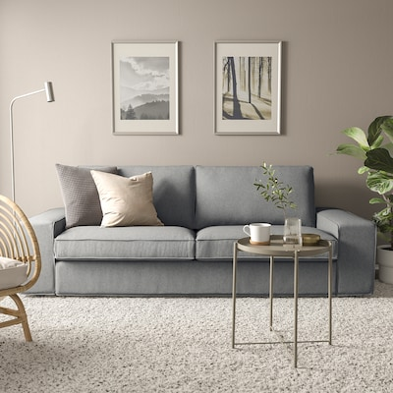

Price

$749

Cuddle up in the comfortable KIVIK sofa. The generous size, low armrests and pocket springs with foam that adapts to the body invites you and your guests to many hours of socializing and relaxation. Enjoy the super comfy KIVIK sofa with deep seat cushions made of pocket springs, high resilience foam and polyester fibers – adding both firm support and relaxing softness. The size and depth of the sofa make it perfect for a nice nap or when the whole family is gathered. There is room for everyone and even extra seating on the wide armrests.

LINANÄS

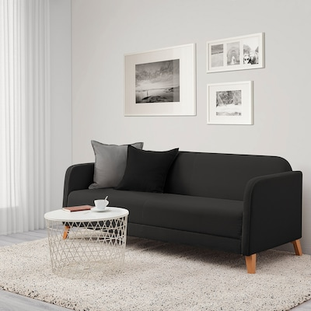

Price

$299

This cover is made from Vissle fabric in polyester, which is dope-dyed. It’s a durable material with a smooth weave and a nice two-tone effect. The LINNANÄS sofa from IKEA is a sleek and comfortable piece of furniture designed for modern living spaces. It's known for its clean lines and contemporary appearance. The sofa is often upholstered in Vissle dark gray fabric, which gives it a sophisticated and versatile look, blending well with various interior styles.

LYCKSELE LÖVÅS

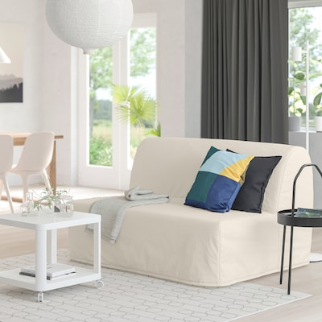

Price

$449

This sofa quickly and easily turns into a bed for two. Easy to keep fresh since the mattress and sofa covers can be removed and washed. Switch between several covers to give the sofa and room a new look. A simple, firm foam mattress for use every night. Extra covers to alternate with mean it's easy to give both your sofa and room a new look. Easily converts into a bed big enough for two.

MORABO

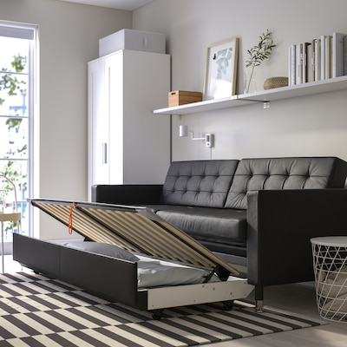

Price

$1,699

Luxury made our way. This sofa has thick grain leather on the exposed surfaces and treated fabric elsewhere – and comes with practical hidden functions like a sofa-bed and storage space under the seat. The contact surfaces are covered with GRANN – a soft, smooth and strong grain leather with natural variations. Other surfaces have BOMSTAD, a coated fabric that has a similar look and feel to leather.

MORABO

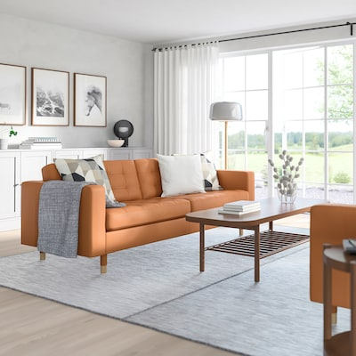

Price

$1,249

Warm and welcoming, neat and stylish. The supporting seat cushions, the cover’s soft finish and the tight fit gives this sofa a perfect balance between its comfort, functions and look. Seat cushions filled with high-resilience foam and polyester fiber wadding provide great seating comfort. These wooden legs give MORABO sofa and armchair a warm and natural look. Removable armrests make it easy to add on a chaise lounge.

MORABO

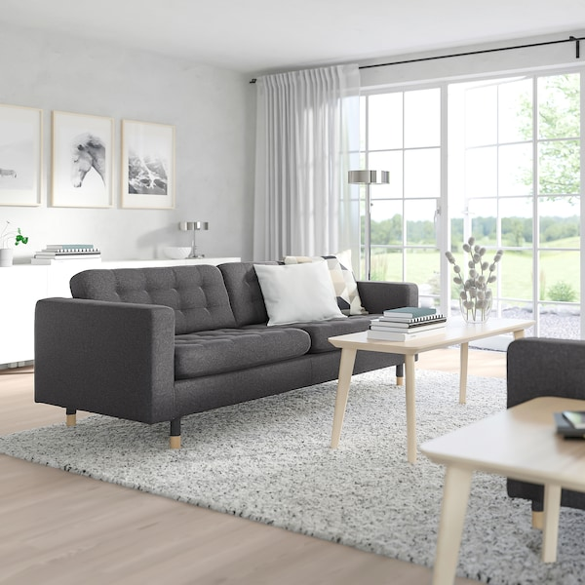

Price

$799

Warm and welcoming, neat and stylish. The supporting seat cushions, the cover’s soft finish and the tight fit gives this sofa a perfect balance between its comfort, functions and look. Seat cushions filled with high-resilience foam and polyester fiber wadding provide great seating comfort. These wooden legs give MORABO sofa and armchair a warm and natural look. Removable armrests make it easy to add on a chaise lounge.

MORABO

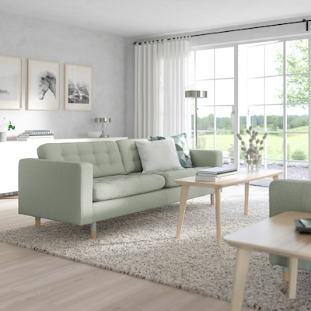

Price

$1,199

Warm and welcoming, elegant and with clean lines. This sofa has a perfect balance of comfort, features and look – with practical hidden functions like a sofa-bed and storage space under the seat. This cover is made of dope-dyed Gunnared fabric in polyester. It is a durable fabric with a wool-like feel, a warm look and a two-toned mélange effect. These wooden legs give MORABO sofa and armchair a warm and natural look.

MORABO

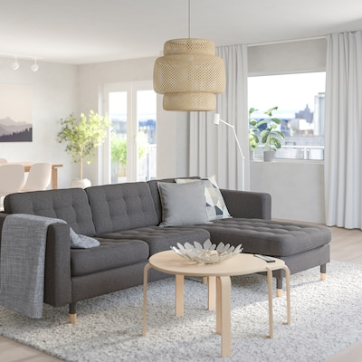

Price

$1,249

Warm and welcoming, neat and stylish. The supporting seat cushions, the cover’s soft finish and the tight fit gives this sofa a perfect balance between its comfort, functions and look. Seat cushions filled with high-resilience foam and polyester fiber wadding provide great seating comfort. These wooden legs give MORABO sofa and armchair a warm and natural look. Removable armrests make it easy to add on a chaise lounge.

PÄRUP

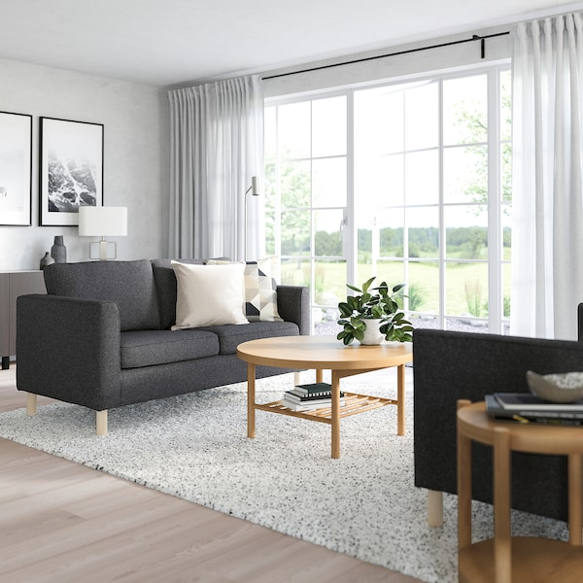

Price

$549

Do you believe in love at first sight? Sleek design, quick assembly and easy-care with a removable and washable cover make it easy to love PÄRUP sofa. Welcoming to all of your loved ones. Timeless design with delicate details such as piping around the armrests and wooden legs. The legs leave space under the sofa in order to create an airy look and make it easier for you when cleaning.

PÄRUP

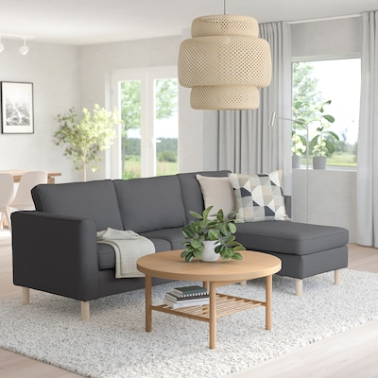

Price

$699

Do you believe in love at first sight? Sleek design, quick assembly and easy-care with a removable and washable cover make it easy to love PÄRUP sofa. Welcoming to all of your loved ones. Timeless design with delicate details such as piping around the armrests and wooden legs. The legs leave space under the sofa in order to create an airy look and make it easier for you when cleaning. The pocket spring core of the seat cushions provides even comfort over the entire seating surface and gives your body good support.

SÖDERHAMN

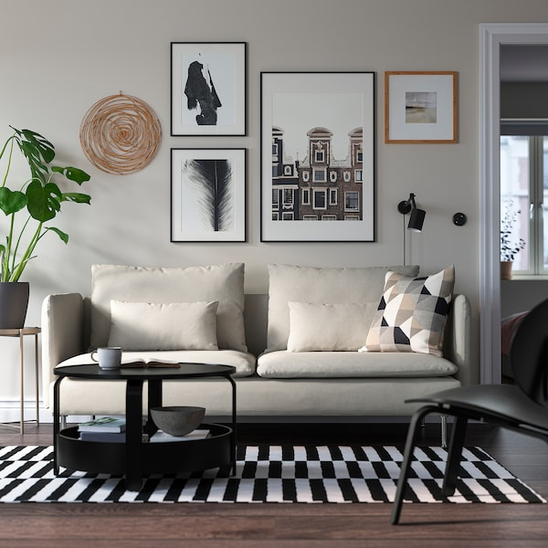

Price

$899

If you like the stylish airy look, you have to try the deep generous seats. Create your own personal combination of SÖDERHAMN sofa, then sit down and relax – by yourself or together with the whole family. SÖDERHAMN seating series allows you to sit deeply, low and softly with the loose back cushions for extra support. Light, airy design with high legs and slim lines, yet still a great comfort thanks to the elastic weave in the bottom and high resilience foam in the seat cushions.

UPPLAND

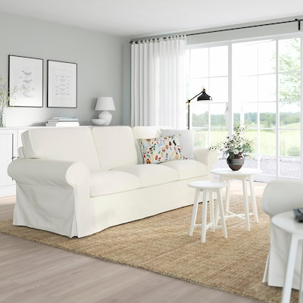

Price

$849

You know the feeling when you sit, lie down or hang out in a sofa, rather than on it. That’s how embracing the deep and generous UPPLAND sofa is – your new favorite place for cozy evenings and lazy days. Enjoy the super comfy UPPLAND sofa with embracing feel and deep seat cushions made of pocket springs, high resilience foam and polyester fibers, adding both firm support and relaxing softness. The cover is easy to keep clean since it is removable and can be machine washed.

VINLIDEN

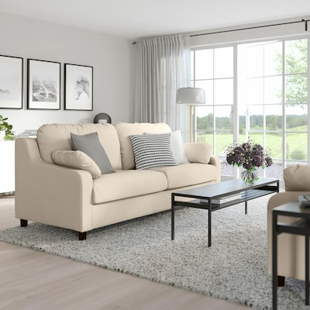

Price

$749

Sitting or lying on VINLIDEN sofa feels like a cozy embrace. You sink into large, soft cushions, and the sofa is also super easy to assemble and disassemble ⎼ so you can take it with you if you move. VINLIDEN sofa has generous proportions with a high back and large, soft cushions that allow you to sink into the sofa. The included small pillows give you nice lumbar support when sitting on the sofa and are perfect to lean your head against when taking a nap.

# 

# Brooks Reclining Sofa

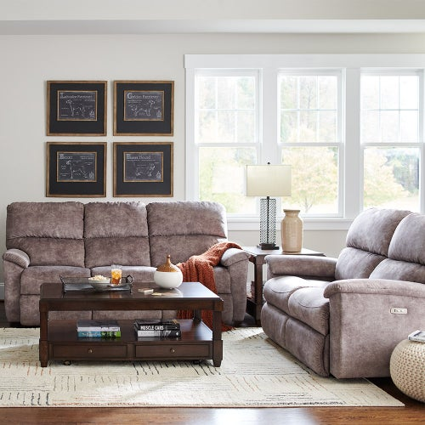

Price

$1,269

The Brooks Reclining Sofa by La-Z-Boy is a plush and inviting piece of furniture designed for comfort and relaxation. It's crafted with high-quality materials and construction, often featuring a sturdy frame and resilient cushioning. This sofa usually includes generously padded seats, backrests, and armrests, providing excellent support for extended lounging sessions. Its reclining mechanism allows for easy adjustment, enabling you to find the perfect position for kicking back and unwinding.

# Laurel Sofa

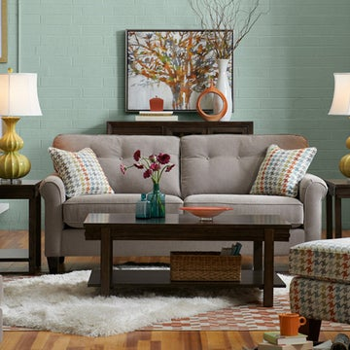

Price

$1,269

The Laurel Sofa by La-Z-Boy is a sophisticated and elegant piece of furniture known for its timeless design and exceptional comfort. It's typically crafted with attention to detail, using high-quality materials and sturdy construction. This sofa often features a classic silhouette with clean lines and graceful curves, lending an air of understated refinement to any room. Its spacious seating area, padded armrests, and plush cushions offer a luxurious and inviting feel. The Laurel Sofa is usually upholstered in a range of fabric or leather options, allowing for customization to suit different preferences and home decor styles. Its versatility in design often makes it a versatile addition to both modern and traditional interiors.

# Morrison Reclining Sofa

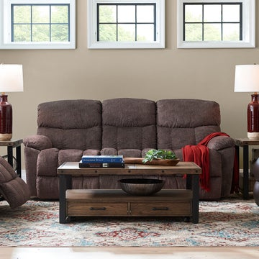

Price

$1,339

The Morrison Reclining Sofa by La-Z-Boy is a comfortable and versatile piece of furniture designed for relaxation and functionality. It's known for its sturdy construction and emphasis on comfort features. This sofa typically boasts a modern and sleek design with clean lines, making it a stylish addition to various home decor styles. The Morrison Reclining Sofa often features generously padded seats, backrests, and armrests, providing excellent support and comfort. What sets this sofa apart is its reclining mechanism, which allows for effortless adjustment to multiple positions, enabling you to find the perfect angle for lounging or resting. This feature is usually accompanied by easy-to-use controls or levers for seamless reclining.

# Natalie Sofa

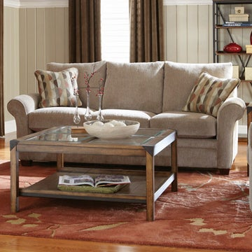

Price

$1,339

The Natalie Sofa by La-Z-Boy is a charming and inviting piece of furniture known for its cozy design and classic appeal. It's crafted with a focus on comfort and style, featuring a blend of traditional elements and modern touches. This sofa typically showcases a timeless silhouette with graceful curves and subtle detailing, adding a touch of elegance to any room. Its design often includes plush cushioning, padded armrests, and a generously sized seating area, ensuring a comfortable lounging experience. The Natalie Sofa is usually upholstered in high-quality fabrics or leather, offering a range of options to suit different preferences and home decor styles. Its versatile design often makes it a versatile addition to various interior themes, whether contemporary or more traditional.

# Joel Reclining Sofa

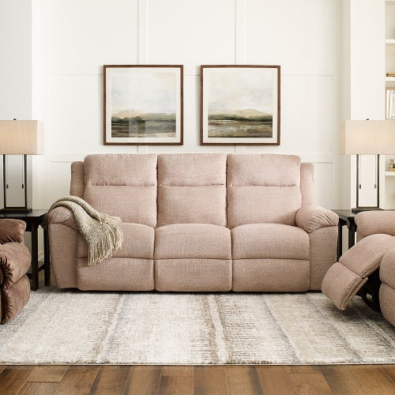

Price

$1,339

The Joel Reclining Sofa by La-Z-Boy is a contemporary and comfortable piece of furniture designed for relaxation and versatility. It's known for its sleek design and emphasis on functionality. This sofa typically boasts a modern and clean-lined appearance, often featuring a streamlined silhouette with padded armrests, generously cushioned seats, and a supportive backrest. The Joel Reclining Sofa offers ample space for seating and lounging, prioritizing comfort without compromising on style.

# Hawthorn Reclining Sofa

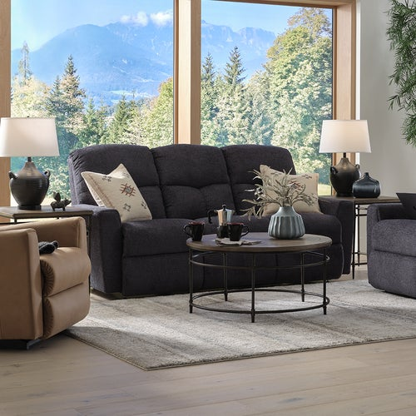

Price

$1,339

The Hawthorn Reclining Sofa typically features a sleek and sophisticated appearance, often showcasing clean lines, plush cushioning, and padded armrests. It offers a spacious seating area with generous padding to ensure comfort during extended lounging periods. This sofa is equipped with a reclining mechanism that allows for effortless adjustment to multiple positions, enabling users to find their preferred angle for relaxation. The easy-to-use controls or levers make reclining smooth and convenient.

# Kennedy Sofa

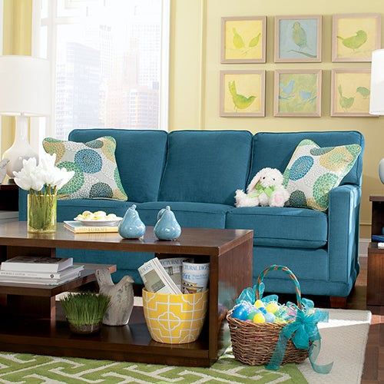

Price

$1,379

The Kennedy Sofa by La-Z-Boy is a timeless and sophisticated piece known for its classic design and exceptional comfort. It's crafted with attention to detail, showcasing both elegance and functionality. This sofa typically embodies a traditional silhouette with graceful curves, rolled arms, and subtle decorative details, exuding an air of timeless charm. Its design often includes deep seating and plush cushioning, ensuring a luxurious and inviting feel.

# Emric Sofa

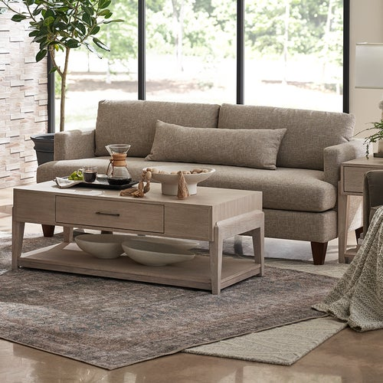

Price

$1,479

A sleek, low profile gives the Emric Sofa a cool, modern air but those pillowy loose back cushions are laid-back and inviting. Framed by shelter track arms, its long, smooth box-edge bench cushion is a spacious and irresistibly cozy spot to chill.

# Amanda Sofa

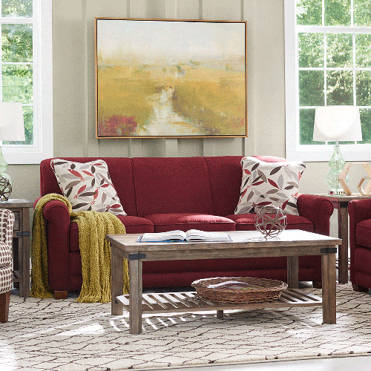

Price

$1,539

Amanda is the understated sofa that blends with most any decor. Its clean, simple design features rolled arms, crisp welt trim and decorative wood legs that make it a perfect fit for any casual room. Amanda’s solid foam back cushions give it a neat and structured appearance, while the patented ComfortCore® seat cushions provide optimum support for a long or short sit. Includes two 20” accent pillows.

# Petra Apartment-Size Sofa

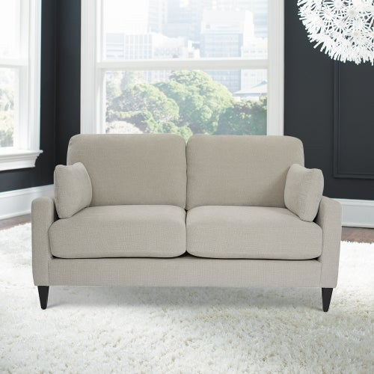

Price

$1,559

Enjoy Petra’s casual, modern edge in a small space. Streamlined cushions, sleek arms, and tapered wood legs lend sophistication. Loose, plush cushions assure pure comfort. Its size is scaled down but the statement it makes in your home is grand. The Petra Apartment-Size Sofa typically featured a more modest footprint compared to larger sofas, making it ideal for apartments, lofts, or smaller rooms. Despite its smaller size, it often offered comfortable seating with generous cushioning and support.

# Kirby Apartment-Size Sofa

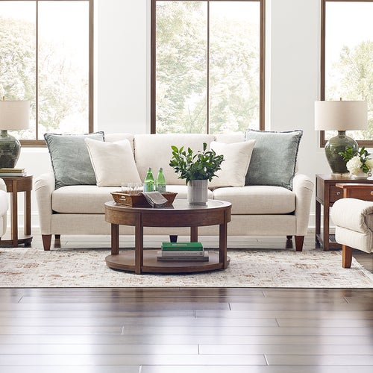

Price

$1,559

The Kirby Apartment-Size Sofa typically featured a more compact design compared to larger sofas, making it a suitable choice for apartments, condos, or smaller rooms. Despite its smaller size, it often provided comfortable seating with ample cushioning and support. In terms of design, the Kirby Apartment-Size Sofa tended to embrace a contemporary aesthetic, often showcasing clean lines, a streamlined silhouette, and minimalistic detailing. This design approach aimed to provide both functionality and a modern look while optimizing space.

# Bexley Sofa

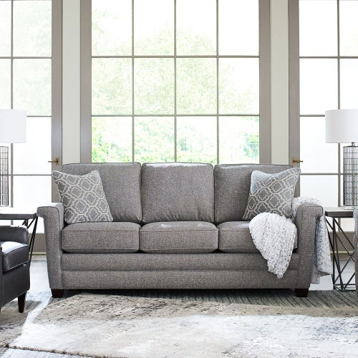

Price

$1,589

The Bexley Sofa often featured a timeless silhouette with elegant rolled arms, subtle detailing, and a gracefully tailored appearance. Its design aimed for a balance between traditional charm and contemporary appeal. Comfort was a priority with the Bexley Sofa, offering ample seating space with well-cushioned seats and supportive backrests. The emphasis on comfort was complemented by its quality construction and materials, ensuring a durable and inviting piece of furniture.

# Pinnacle Wall Reclining Sofa

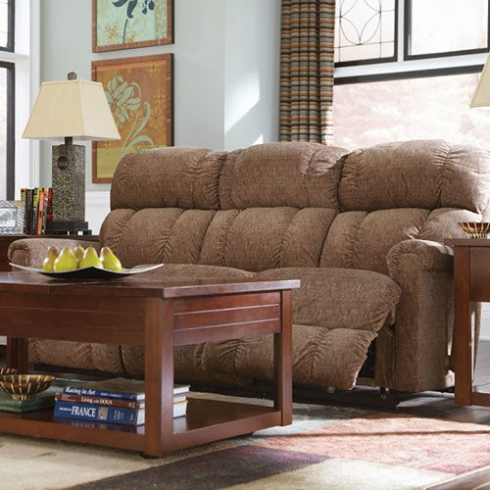

Price

$1,599

The Pinnacle Wall Reclining Sofa by La-Z-Boy is a comfortable and functional piece of furniture designed for optimal relaxation and convenience. It's known for its innovative features and comfort-focused design. This sofa typically features a contemporary and streamlined appearance, offering a modern look with clean lines and minimalistic detailing. It's equipped with a wall reclining mechanism, allowing it to recline smoothly even when placed close to a wall, saving space and providing flexibility in room arrangement.

# Collins Sofa

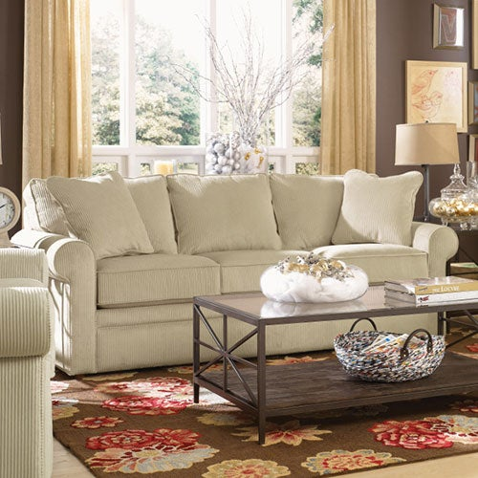

Price

$1,599

The Collins Sofa by La-Z-Boy is a blend of modern style and plush comfort. This sofa typically embodies a contemporary design with clean lines and a streamlined silhouette, making it a versatile addition to various interior aesthetics. Known for its spacious seating, the Collins Sofa offers ample room for relaxation with generously padded seats, supportive backrests, and cushioned armrests. Its design prioritizes comfort without compromising on a sleek and sophisticated appearance.

# Meyer Sofa

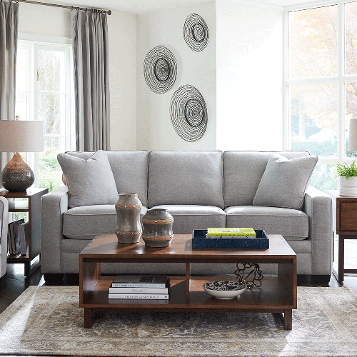

Price

$1,599

The Meyer Sofa often features a sleek and modern silhouette with clean lines, squared arms, and subtle detailing. Its design aims for a balance between contemporary style and comfort. Comfort is a key feature of the Meyer Sofa, offering a spacious seating area with generously padded cushions, supportive backrests, and well-cushioned armrests. The emphasis on comfort is complemented by its durable construction and quality materials, ensuring a comfortable and long-lasting piece of furniture.

# Mackenzie Sofa

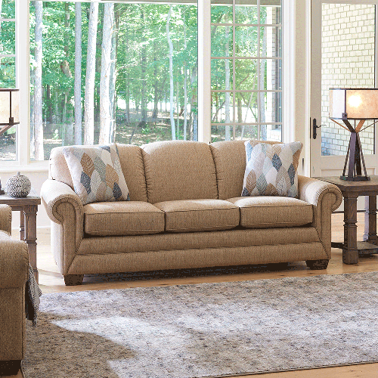

Price

$1,699

The Mackenzie Sofa often features a traditional silhouette with gently rolled arms, elegant detailing, and a refined appearance. Its design aims to offer a balance between timeless charm and contemporary comfort. Comfort is a priority with the Mackenzie Sofa, providing a spacious seating area with well-padded cushions, supportive backrests, and comfortably designed armrests. Its emphasis on comfort is complemented by its durable construction and the use of high-quality materials, ensuring both comfort and longevity.

# Petra Extra Long Sofa

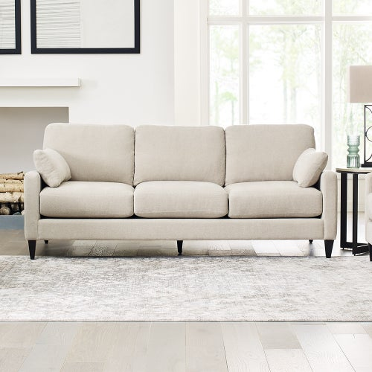

Price

$1,699

This sofa typically featured an elongated design with ample seating space, allowing for comfortable lounging or accommodating multiple individuals. Its style often leaned towards modern and contemporary aesthetics, with clean lines and a sleek silhouette. Comfort was a focal point of the Petra Extra Long Sofa, providing generously padded cushions, supportive backrests, and well-designed armrests. Its emphasis on comfort aimed to cater to extended relaxation or gatherings.

# James Reclining Sofa

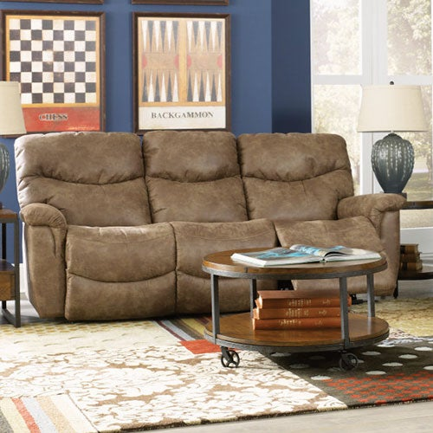

Price

$1,699

The James Reclining Sofa by La-Z-Boy is a combination of comfort and functionality, designed for relaxation and versatility. This sofa is recognized for its practicality and comfort features. It typically showcases a contemporary design with clean lines and a sleek silhouette, offering a modern look while prioritizing comfort. The James Reclining Sofa is equipped with reclining capabilities, allowing for effortless adjustment to various positions, providing personalized comfort for lounging or resting.

# Paxton Sofa

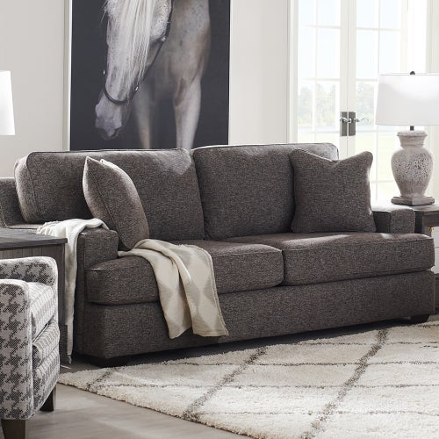

Price

$1,799

Our new Paxton Sofa is the casual and relaxed sofa that invites you to kick back and get cozy. But its clean lines and crisp welt trim give it a neat and structured silhouette. Paxton features deep, T-shaped seat cushions, low-profile wood legs and chamber-filled back cushions that maintain their shape and support over time. Patented ComfortCore® cushions provide just the right amount of support for a long or short sit. A matching ottoman is available separately.

# Robin Power Reclining Chair

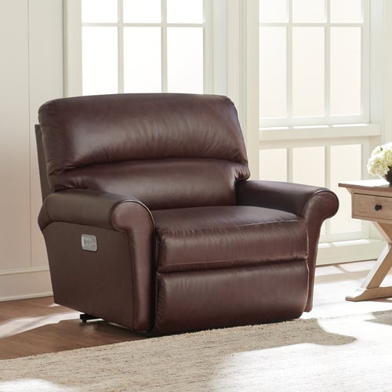

Price

$1,869

The Robin Power Reclining Chair and a Half with Headrest & Lumbar by La-Z-Boy is a luxurious and ergonomically designed seating option known for its comfort and advanced features. This chair and a half typically offer an oversized seat compared to a standard chair, providing ample room for relaxation. It comes equipped with power reclining functionality, allowing smooth and effortless adjustment to various positions using an integrated control panel.

# Trouper Reclining Sofa

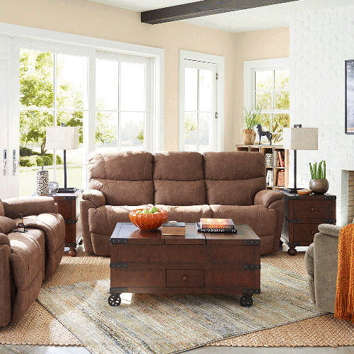

Price

$1,909

This sofa typically features a casual and inviting design, often with plush cushioning, generously padded armrests, and supportive backrests. It's designed to offer a cozy seating experience, whether for relaxing with family or entertaining guests. The Trouper Reclining Sofa incorporates reclining capabilities, allowing you to effortlessly adjust the seats to multiple positions for personalized comfort. Its reclining mechanism is user-friendly and smoothly transitions for easy lounging.

# Apollo Reclining Sofa

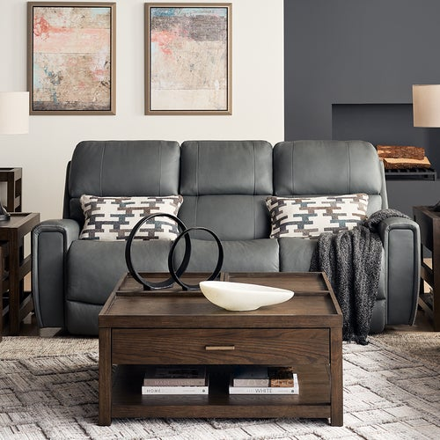

Price

$1,909

This sofa typically boasts a modern and sleek appearance, featuring clean lines, a streamlined silhouette, and subtle yet stylish detailing. Its design aims to provide a blend of sophistication and comfort. Comfort is a key focus of the Apollo Reclining Sofa, offering generously cushioned seats, supportive backrests, and padded armrests. Its design prioritizes relaxation and coziness while maintaining a contemporary aesthetic.



AMERSHAM

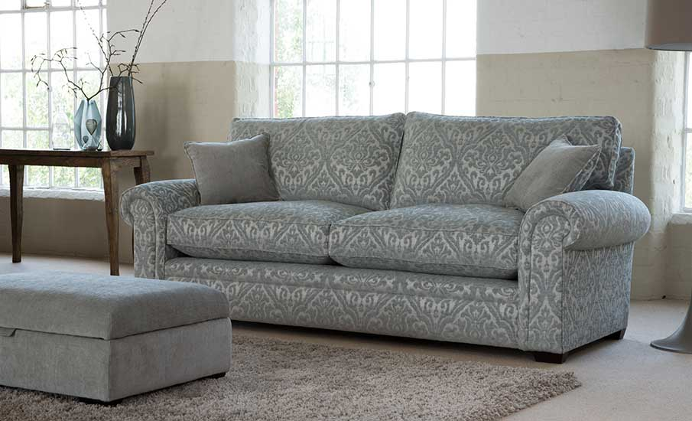

Price

$1,269

A collection that brings a new meaning to the word ‘comfort’. Our sumptuous Amersham collection is a classic, timeless design that has been modernized to simplify lines and provide a focus on nothing but comfort. A timeless suite with clean and contemporary lines, the Amersham is handmade in Britain by our expert craftsman using our latest innovation in premium comfort technology. The suite is available in soft touch fabrics or high-quality leather. Available as a two seater sofa, a grand sofa, snuggler and armchair.

### **BOSTON**

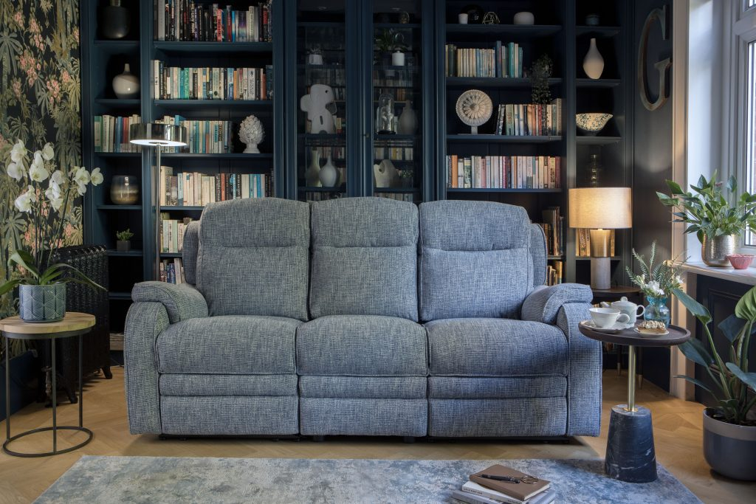

Price

$1,349

The Boston range provides the ultimate relaxation. Featuring a high back, and supportive seating, with an option of a static or electronic reclining system. This range combines small compact proportions with neatly tailored details. The Boston is handmade in Britain by our expert craftsman, and includes a stainless-steel USB charging port on power recliner models. Available as a three-seater sofa, large two-seater sofa, two-seater sofa, or armchair.

### **BRADSHAW**

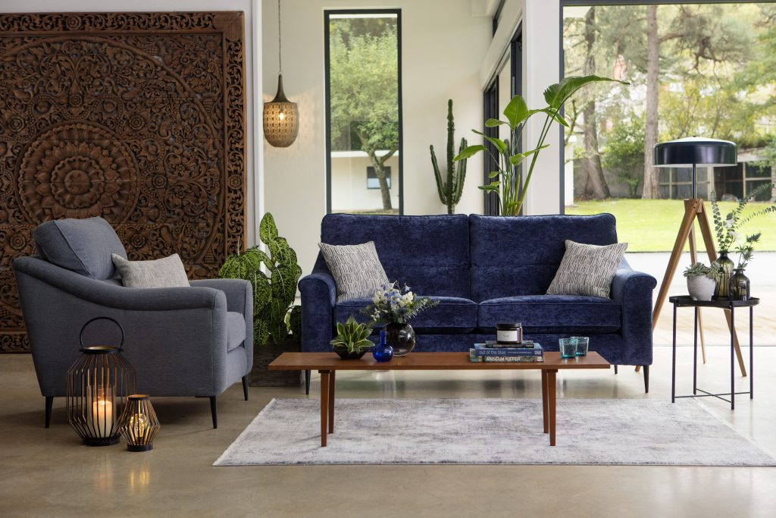

Price

$1,339

Bradshaw offers a hint of mid-century charm and contemporary styling with its modern lines and sleek metal legs. Choose a bold scatter to pack a punch with this show stopper. Available as a chair, two-seater and three-seater sofa. Includes scatter cushions. Ultra-comfy with premium comfort foam seats. This technology has been developed by us to create an ultra-comfy seating experience – the best we have ever tested! It has a foam core, with a super soft topper, that will conform to your body shape, but bounces back and holds its shape.

### **BRADY**

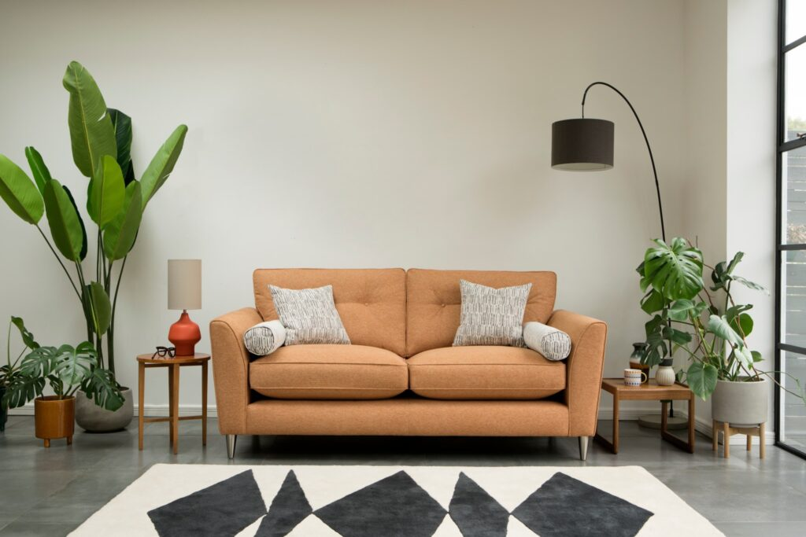

Price

$1,339

This deep seated, button-back beauty, will be sure to add a hint of glamour to your space. Featuring stylish high legs, and our ultra-comfy seating interiors, Brady is the perfect choice if you are looking to combine both style and comfort. An ultra-comfy, super-stylish collection, that can withstand everything life, little ones, and pets, can throw at it. Ultra-comfy with premium comfort foam seats. This technology has been developed by us to create an ultra-comfy seating experience – the best we have ever tested! It has a foam core, with a super soft topper, that will conform to your body shape, but bounces back and holds its shape.

### **BURGHLEY**

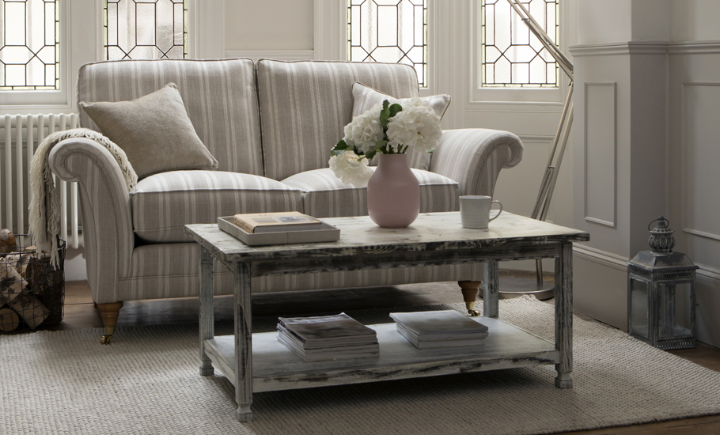

Price

$1,339

The Burghley collection boasts classic silhouettes and exquisite detailing, making it one of our most elegant suites. The formal high back employs elasticated webbing for a wonderful posture and support, whilst the seats are filled with our finest fibre technology giving you ultimate comfort whilst helping to maintain the seats shape.

A timeless suite, the Burghley is handmade in Britain by our expert craftsman using our latest innovation in premium comfort technology. The suite is available in soft touch fabrics or high-quality leather. Available as a grand sofa, large and standard two-seater, and an armchair. Includes scatter cushions.

### **CANTERBURY**

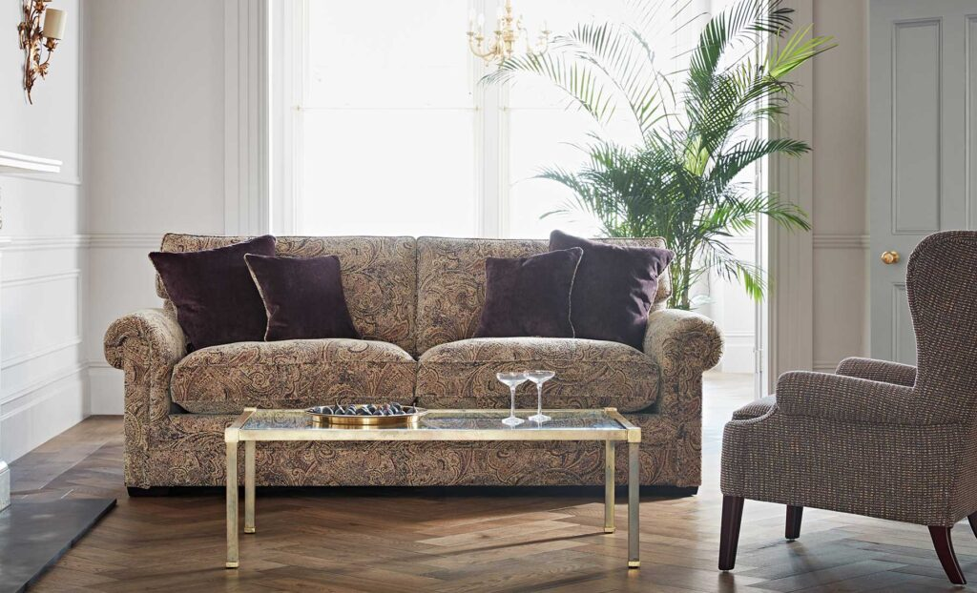

Price

$1,339

The Canterbury suite is a stylish addition to any home. With luxurious padded seats, rolled, supportive arms, and plump matching scatter cushions, this suite gives the ultimate comfort experience. A classic suite, the Canterbury is handmade in Britain by our expert craftsman using our latest innovation in premium comfort technology. The suite is available in soft touch fabrics or high-quality leather. Available as a grand sofa, large and standard two-seater, and an armchair. Includes scatter cushions.

### **CHICAGO**

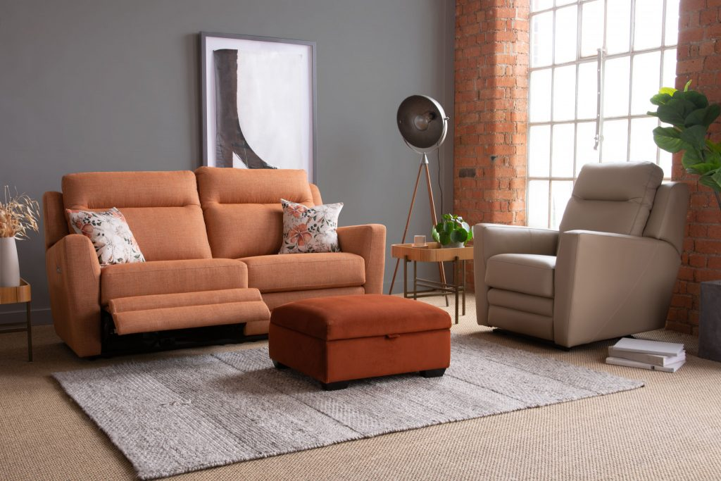

Price

$1,379

Due to its high back support and graceful sweeping lines, Chicago is an understated staple for any contemporary space. Moreover, with the ability to upgrade to a rechargeable power pack, Chicago may offer a simple, clean aesthetic but it’s not to be underestimated ergonomically. Carefully crafted in Britain by pioneers in the industry, transform your seating experience with Parker Knoll. We proudly present you with an adjustable footrest, headrest and lumbar support for unparalleled comfort.

### **COLORADO**

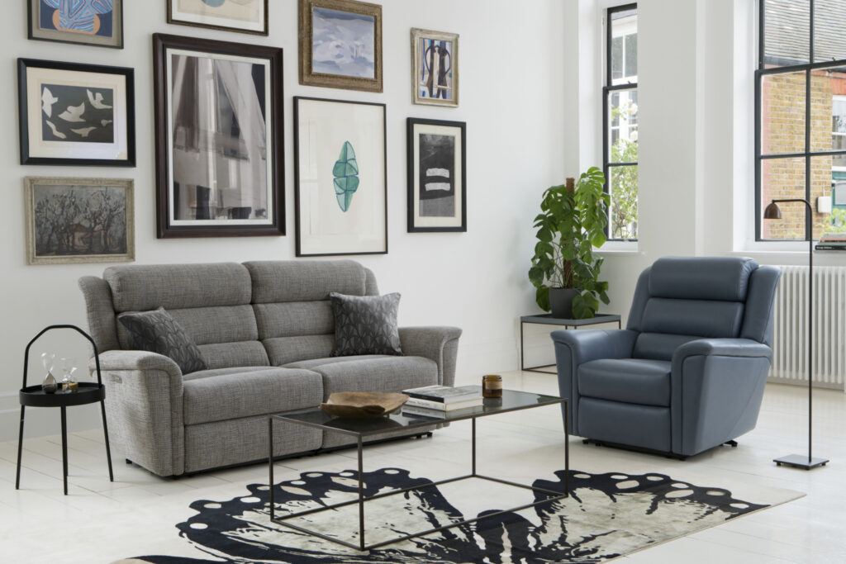

Price

$1,479

A contemporary suite that combines both comfort and style. With curved, clean lines and a three tiered cushioned back, this contemporary classic is the perfect addition to any home. Available to upgrade to an electronic reclining system with a USB port so both you and your devices can recharge. Handmade in Britain by our expert craftsman using our latest innovation in premium comfort technology. The suite is available in soft touch fabrics or high quality leather. Available as a chair or two seater sofa with the option of a powered recliner.

### **COOPER**

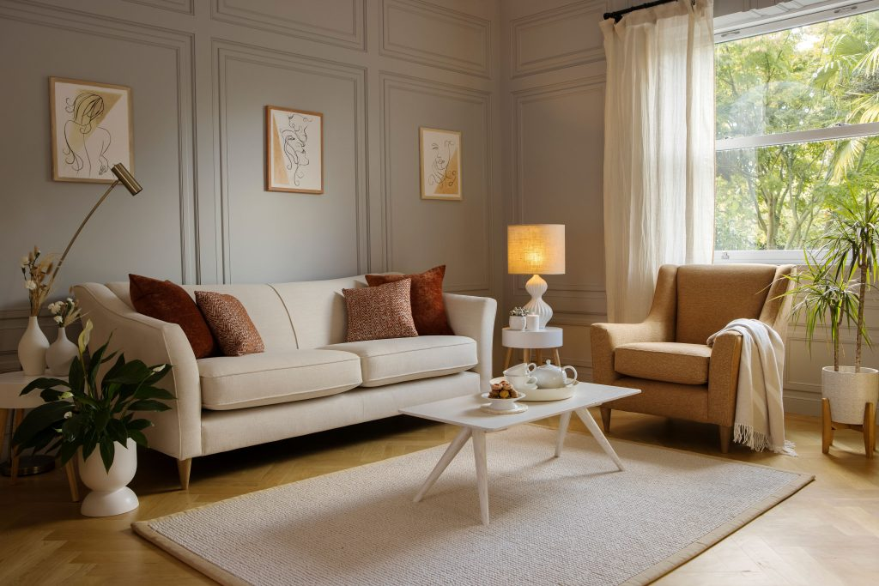

Price

$1,539

With it’s foam seating and fixed back, Cooper provides clean lines and supportive comfort. Contemporary turned legs give a hint of mid-century style. Perfect for everyday life and all the little mishaps that may happen. Available as a chair, snuggler, 2 seater and 4 seater. Includes large scatter cushions. Ultra-comfy with premium comfort foam seats. This technology has been developed by us to create an ultra-comfy seating experience – the best we have ever tested! It has a foam core, with a super soft topper, that will conform to your body shape, but bounces back and holds its shape.

### **DAKOTA**

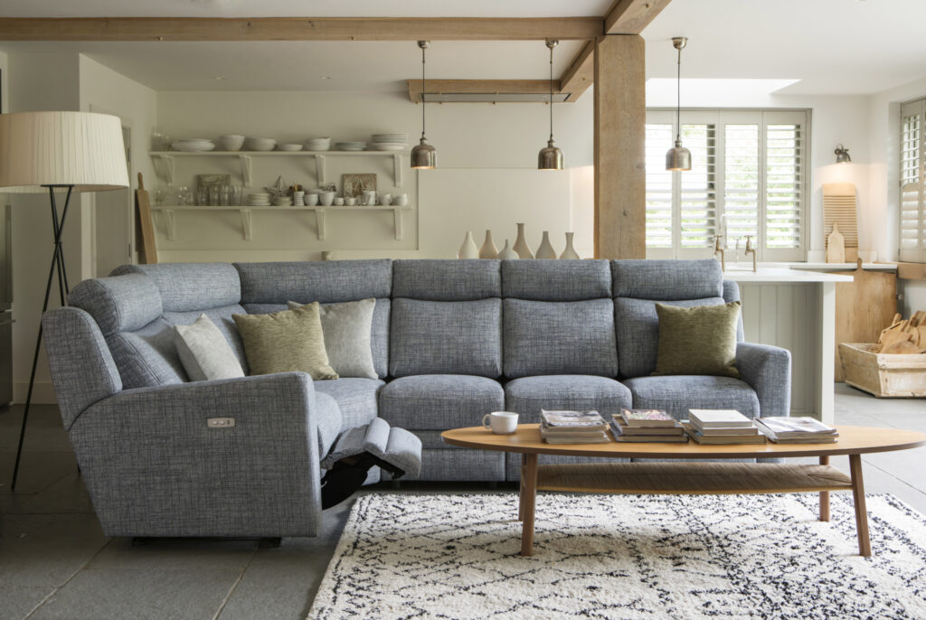

Price

$1,559

Each piece within the Dakota collection exudes an air of understated elegance, characterized by clean lines, subtle curves, and a harmonious blend of materials. From luxurious upholstery to polished finishes, every element contributes to its chic yet versatile appeal. This collection offers a range of furniture options, from sofas and armchairs to sectional pieces, all tailored to seamlessly complement a contemporary living space. With the option of a powered recline, it effortlessly caters to comfort while maintaining its sleek profile. Additionally, the inclusion of a neatly integrated USB port adds a modern touch, allowing for convenient charging of devices without compromising on style.

### **DEVONSHIRE**

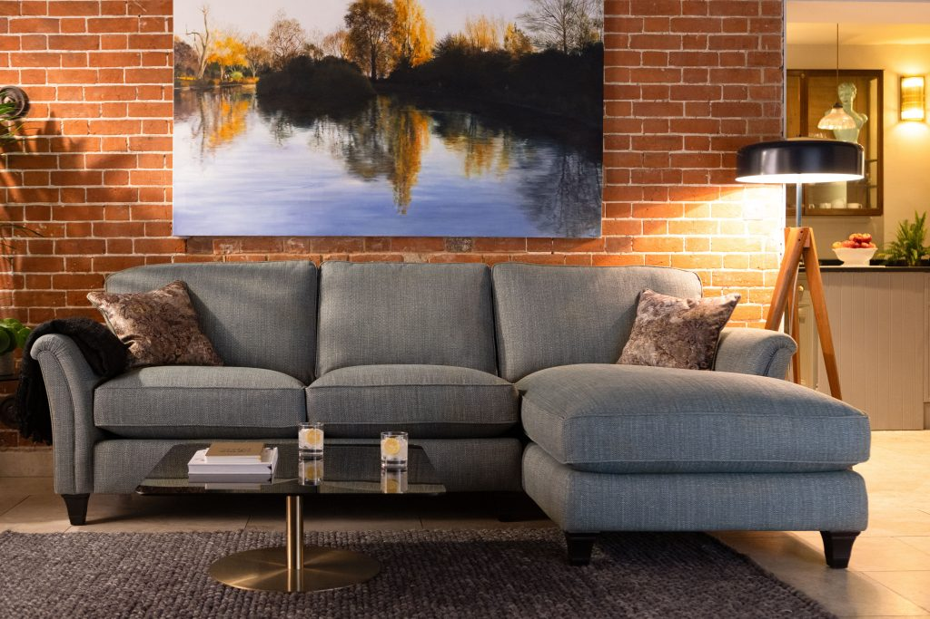

Price

$1,559

The Devonshire collection is the ultimate casual classic. Relax on sprung seats and feel supported and pampered by the deep, luxury fibre-filled cushions which keep their shape beautifully. A classic suite, the Devonshire is handmade in Britain by our expert craftsman using our latest innovation in premium comfort technology. The suite is available in soft touch fabrics or fine leathers. Choose between a pillow back or formal back, and contemporary or traditional legs. Available as a chair, large and standard two seater, grand, cornergroup and chaise end sofa.

### **GRIFFIN**

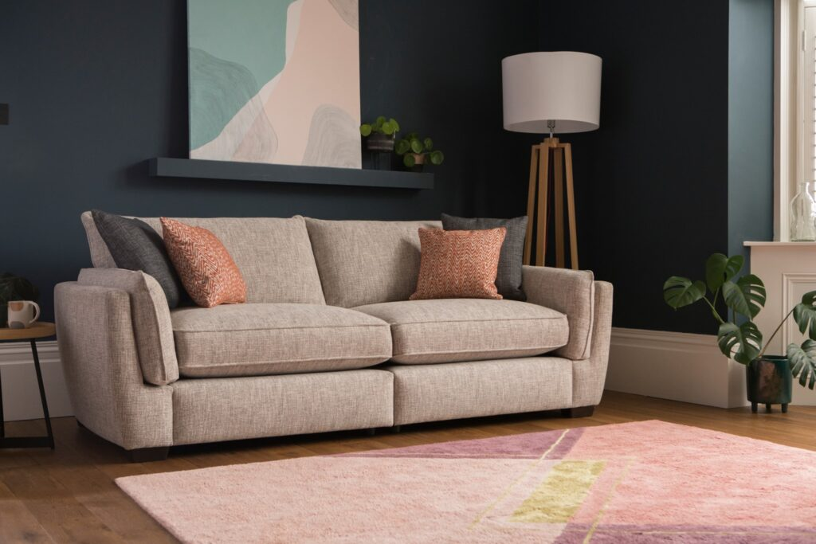

Price

$1,589

Griffin is every bit as comfy as it looks. Relax into Griffin’s sink-into cushions, and added arm-pads, for the perfect chill-out experience. An ultra-comfy sofa, designed with sticky hands and muddy paws in mind. Griffin is ready for anything life throws at it. Ultra-comfy with premium comfort foam seats. This technology has been developed by us to create an ultra-comfy seating experience – the best we have ever tested! It has a foam core, with a super soft topper, that will conform to your body shape, but bounces back and holds its shape.

### **HAMPTON**

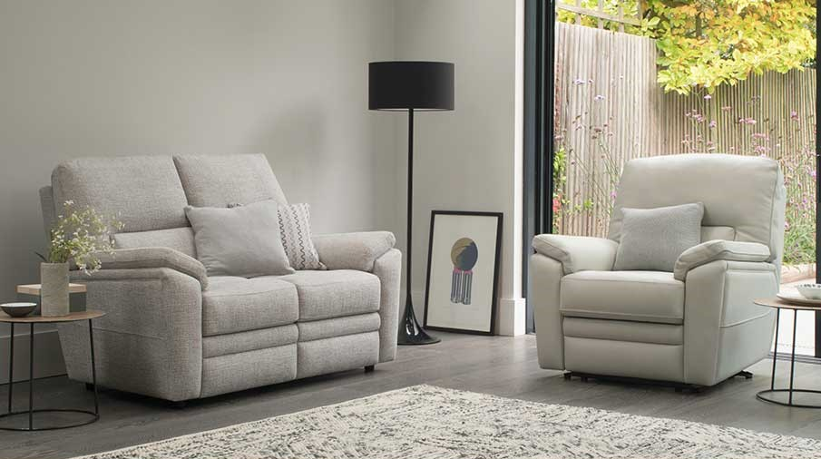

Price

$1,599

If you are looking for style and comfort, the Hampton collection is for you. With a high back, padded arms and a reclining seat, you can enjoy time relaxing in this classic design. This statement collection is handmade by our expert craftsman using our latest innovation in premium comfort technology. Available in soft touch fabrics or fine leathers. Available as an armchair, a large or standard two seater.

### **HAZEL**

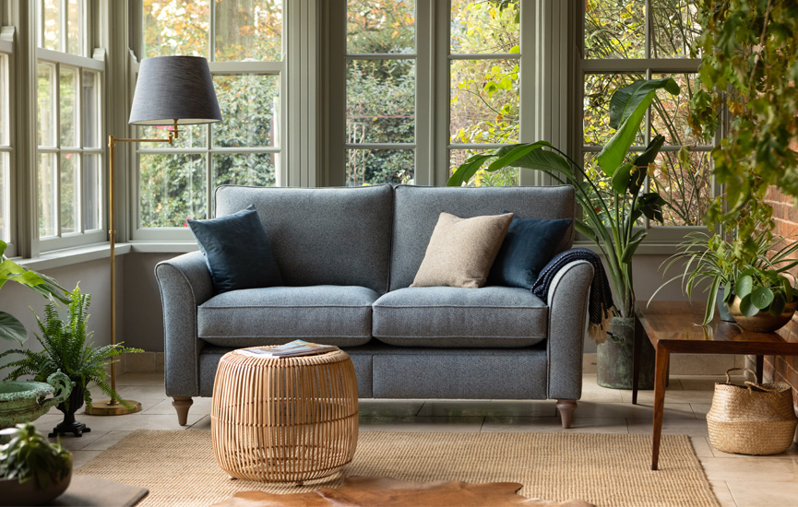

Price

$1,599

As part of our effort to be more conscious to the planet, we are delighted to showcase Hazel.  Each piece in the evolve collection is recycled. Moreover, every sofa repurposes around 170 bottles so the only thing you need to feel guilty about is how comfortable you are when sitting in Hazel’s deep and contouring cushions. Hazel’s naturalistic and timeless silhouette is built to last by our specialist craftspeople in rural Nottinghamshire and with a 25-year guarantee, we can endeavour to minimise waste together.

### **HENLEY**

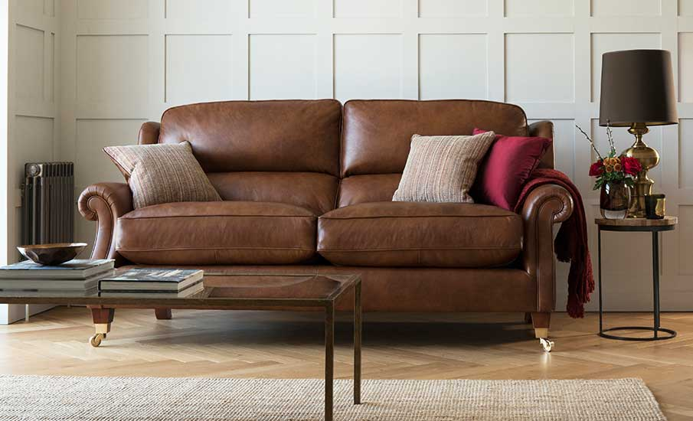

Price

$1,599

A timeless collection, the Henley offers high backs and classic detailing. It’s serpertine springs, elasticated webbed back support and deep fibre filled cushions ensures wonderful posture and support, taking you to the height of comfort. This elegant collection is handmade by our expert craftsman using our latest innovation in premium comfort technology. Available in soft touch fabrics or fine leathers. Available as a  standard and powered footrest chair, large or standard two seater. Includes scatter cushions.

### **HOXTON**

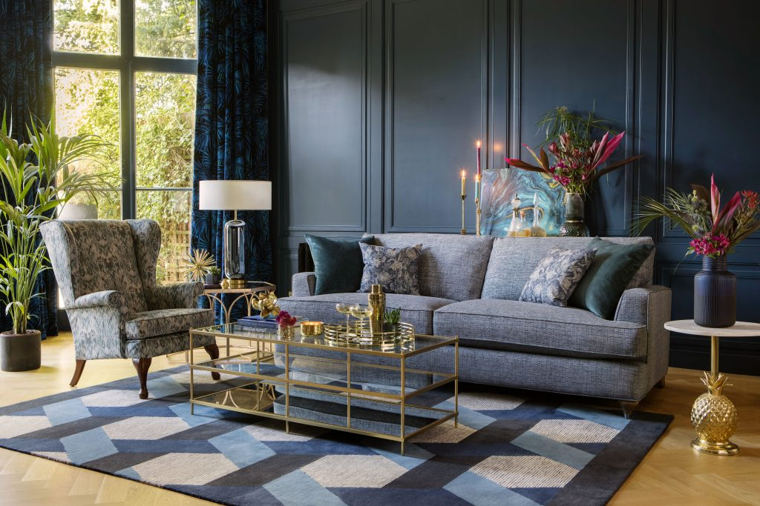

Price

$1,699

An iconic collection, the Hoxton’s shape is inspired by the art deco period with a modern twist. It’s straight lines and exquisite detailing make this a contemporary addition to any home. Comfort isn’t compromised and this collection is available with our premium comfort foam or Encore fibre technology. This contemporary collection is handmade in Britain by our expert craftsman using our latest innovation in premium comfort technology. Available in soft touch fabrics. Choose from two wood finishes and embellish the stylish turned legs with a choice of brushed chrome or brass slipper cups. Available as a chair, large and standard two seater and a grand sofa. Includes scatter cushions.

### **MANHATTAN**

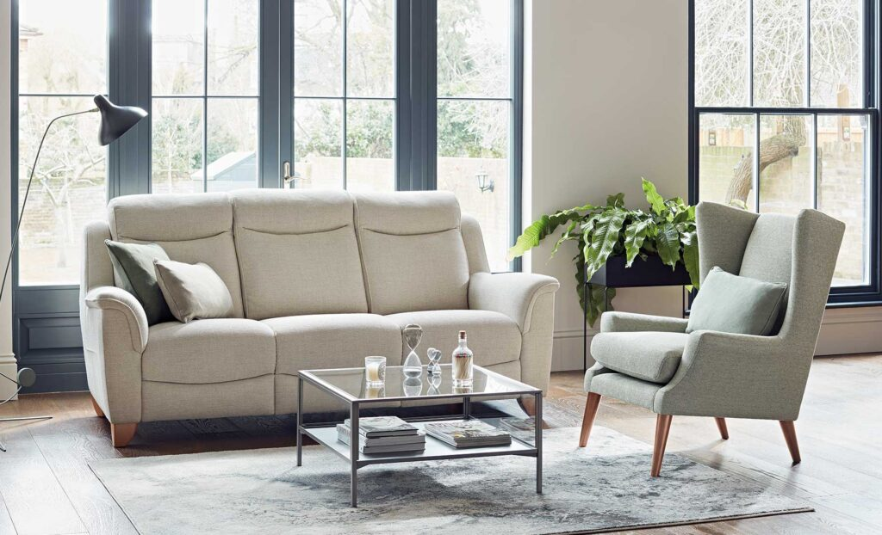

Price

$1,699

A classic collection with clean sweeping lines, high back comfort and deep cushioning. Powered with an electronic reclining system and a modern-style USB port, this range offers everything you need to relax. Available with a cordless power option which will provide 80 – 100 cycles once fully charged. This collection is handmade in Britain by our expert craftsman using our latest innovation in premium comfort technology. Available in soft touch fabrics or fine leather. Available as a chair, two or three seater sofa.

### **MICHIGAN**

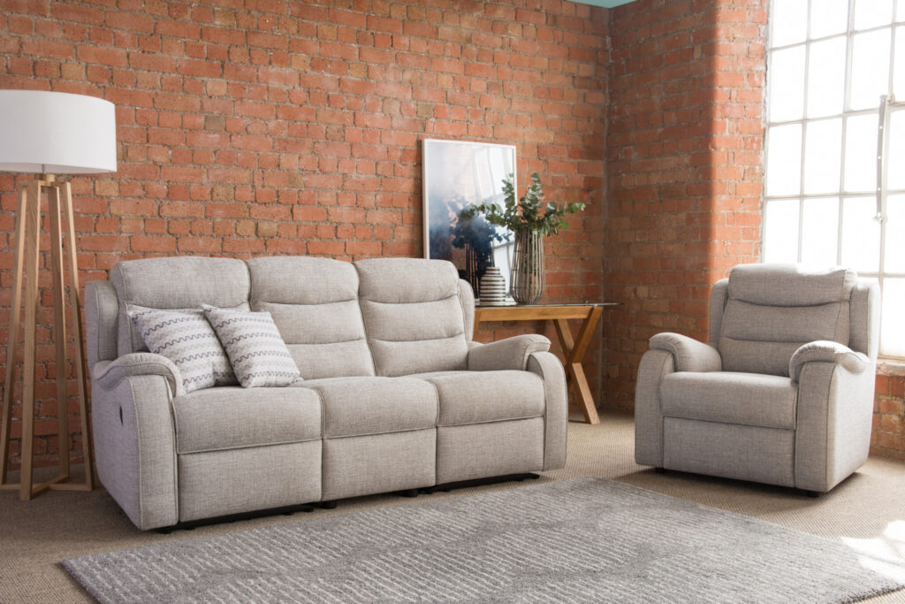

Price

$1,699

Combining comfort and style the Michigan collection will help you create a relaxed and stylish living space. With deep cushions, a high back, and manual reclining system, this range offers the perfect comfort experience. This collection is handmade in Britain by our expert craftsman using our latest innovation in premium comfort technology. Available in plain or patterned soft touch fabrics. Available as an armchair, two or three seater sofa.

### **OAKHAM**

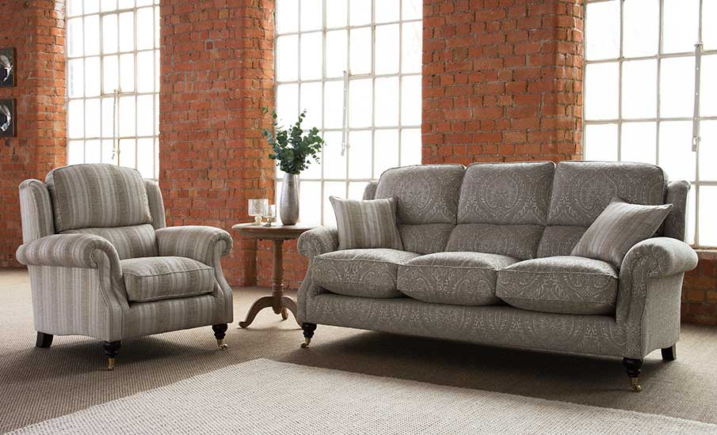

Price

$1,799

The Oakham collection represents the height of comfort. With high backs and classic detailing, Oakham is timeless. This collection is handmade in Britain by our expert craftsman using our latest innovation in premium comfort technology. Available in soft touch fabrics or fine leather. Available as an Armchair, large and standard two seater, and a three seater sofa. Includes scatter cushions.

### **PENSHURST**

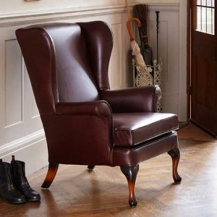

Price

$1,869

Our classic Penhurst chair has over 70 years of heritage. It’s stately back, gently curved cushions and tapered legs, combined with the ultimate comfort experience thanks to it’s innovative spring system, will give timeless elegance to any room. Handmade in Britain by our expert craftsman using our latest innovation in premium comfort technology. Available in soft touch fabrics or fine leather.

### **PORTLAND**

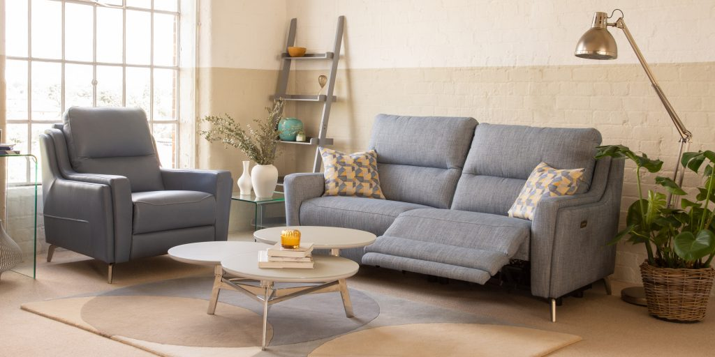

Price

$1,909

The Portland has sleek and minimalistic lines inspired by beautiful Italian designs, which are perfect to make a bold style statement within an open plan space. Whilst this collection boasts an impeccable balance of style, it still has the quintessentially Parker Knoll comfort you can depend on. Handmade in Britain by our skilled craftsmen and women, Portland is also available as a power recliner, which has been meticulously designed to provide you with the ultimate state of relaxation. Complete with our innovative and compact USB port.

### **ROWAN**

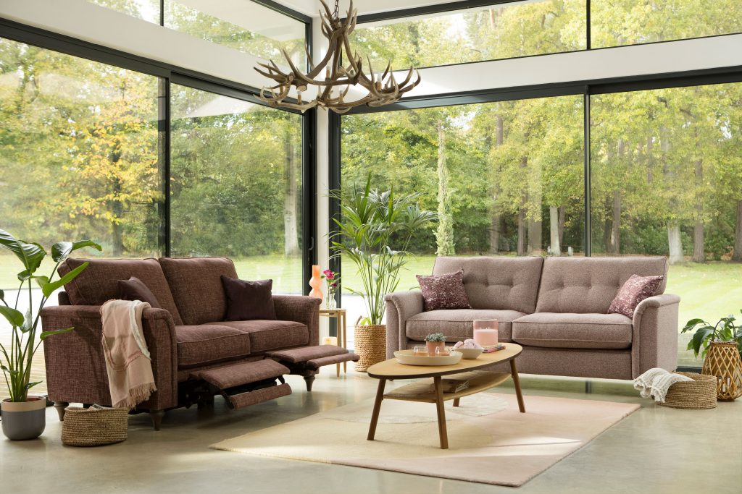

Price

$1,909

This consciously crafted range has deep interiors that are made with 50% recycled ocean plastics and uses soft recycled fabrics made from regenerated yarns and upcycled cotton; so you can help the planet whilst sitting comfortably. With the option of a button-back or plain back, Rowan is beautiful on the outside and in. Expertly engineered in rural Nottinghamshire this model is also available with our distinctive power footrest option so you can rest easy knowing you’ve done your bit to help our planet.

### **SIMPSON**

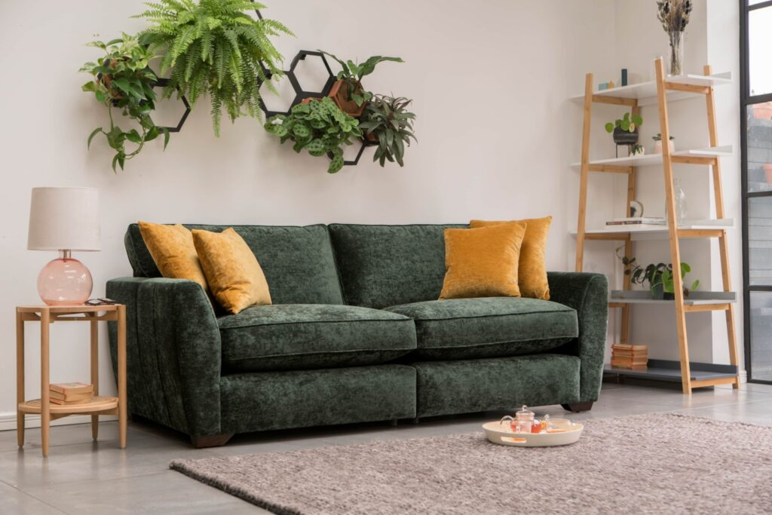

Price

$1,909

The Simpson is the perfect for those who love to put their feet up after a long day! With super-comfy cushions, Simpson will be your new favourite snuggle-spot. With beautiful arm stitching, and clean lines, this sofa will also add bags of style to your living room! Designed with real-life in mind, Simpson will be your comfy companion that has your backs (and your bottoms), day in, day out. Ultra-comfy with premium comfort foam seats. This technology has been developed by us to create an ultra-comfy seating experience – the best we have ever tested! It has a foam core, with a super soft topper, that will conform to your body shape, but bounces back and holds its shape.

### **WESTBURY**

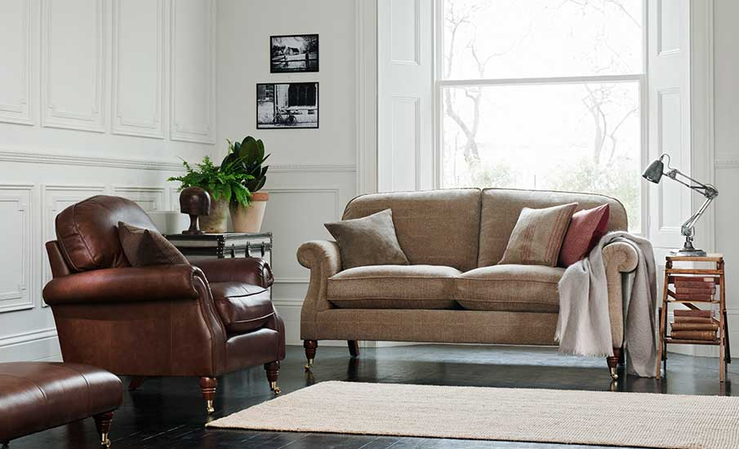

Price

$1,909

A design of classic elegance, the Westbury exudes timeless style with scroll arms and castor feet. This collection offers true relaxation with a choice of seat fillings for your comfort appeal. Handmade in Britain by our expert craftsman using our latest innovation in premium comfort technology. Available in soft touch fabrics or fine leather. Available as a grand sofa, a large and standard two seater, and an armchair. Includes scatter cushions.